World Wood Day Events in Dar es Salaam, Tanzania, March 19-23, 2013

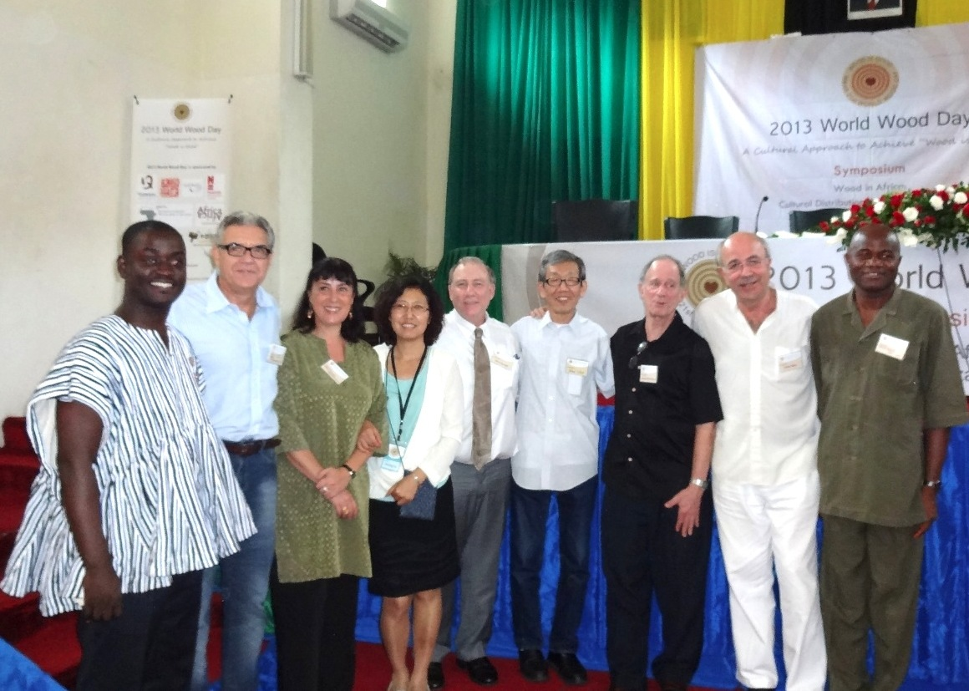
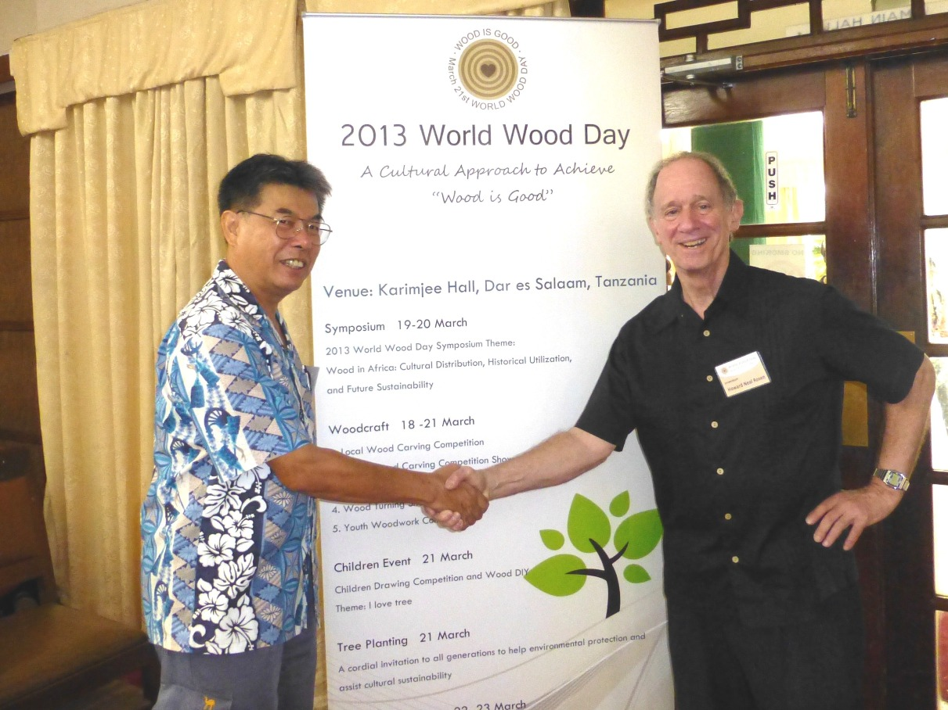

Andrew Wong, Division 5 Coordinator, and Howard Rosen, Wood Culture 5.10.01 Working Party Chair, attended the first World Wood Day (WWD) conceived by The International Wood Culture Society (IWCS), March 21, 2013. March 21, 2013 was officially recognized as the first International Day of Forests (IDF) by the United Nations General Assembly and WWD was celebrated on the same day to raise the awareness on how wood plays a key role in the sustainable future of our forests and society, adding meaning to the IWCS mantra that “Wood is Good.” The WWD events were held at Karimjee Hall, Dar es Salaam, Tanzania, on 19 – 23 March 2013. On 21 March morning, a formal Opening ceremony of the WWD and IDF celebrations was enhanced by the presence of the Deputy Minister of Natural Resources and Tourism, Lazaro Nyalandu, whose speech emphasized the need for protection of Tanzania’s forest resources for a sustainable wood industry for future generations. The Deputy Minister and delegates then toured the wood carving show (pictured) and planted a tree to commemorate the WWD and IDF. The WWD events also included a 2-day World Wood Day technical symposium on “Wood in Africa: cultural distribution, historical utilization and future sustainability” (shown are several of the symposium speakers and moderators), a Tanzanian wood carving competition, a pan-African wood carving competition, an international wood carving and wood turning show, youth woodworking competition, a children’s drawing competition related to trees, and a formal tree-planting ceremony on 21 March, to commemorate the twin WWD-IDF occasion. The culmination was a celebration of WWD with entertainment and the presentation of prizes for the winners of the competitions. Over 300 people from 45 countries attended this meeting. The International Wood Culture Society was the main organizer of this event and IUFRO was one of the sponsors.

On 22 March, many of the attendees traveled to a local forest and planted tree seedlings (coordinated by the Tanzanian Forest Service) to emphasize the need for a sustainable source of trees to continue making wood products. A tour to a regional vocational training center and an ebony wood carving market completed the day. More details on these meetings and tours can be found at the IWCS World Wood Day website “www.worldwoodday.org.”

Andrew Wong
IUFRO Division 5 Coordinator

Howard Rosen
IWCS – Vice President and IUFRO 5.10.01 Wood Culture Working Party Chair

