IUFRO Task Force Proposal 2017-2019
Monitoring global tree mortality patterns and trends
Task Force Coordinator:
Tanja Sanders (Thünen Institute of Forest Ecosystems, Germany)
Task Force Members (in alphabetical order):

Andreas Bolte (Thünen Institute, Chair of TF Forest Adaptation and Resoration under Global Change, Deputy
Aster Gebrekirstos (World Agroforestry Centre, Kenya)
Belinda Medlyn (University of Western Sydney)
Bernhard Schuldt (University of Goettingen, Germany)
Cate Macinnis-Ng (University of Auckland, New Zealand)
Choy Huang (National Taiwan University, Taiwan)
Christoph Leuschner(University of Göttingen, Germany)
Christopher Reyer (Potsdam Institute of Climate Impact Research, Germany)
Craig D. Allen (USGS, New Mexico Landscapes Field Station, U.S.A.)
David Coomes (University of Cambridge, Great Britain)
Eugene Vaganov (Siberian Federal University, Russia)
Gabriel Arellano Torres (Smithsonian Tropical Research Institute, U.S.A.)
Gaia Vaglio Laurin (Earth Observation DIBAF, Italy)
Geerten M. Hengeveld (Wageningen University and Research, The Netherlands)
Hans Juergen Boehmer (University of the South Pacific, Fiji Islands)
Henrik Hartmann(MPI Jena, Germany)
Irina Sviderskaya (Siberian Federal University, Russia)
Jordi Martínez Vilalta (UAB, Spain)
Josep Peñuelas(CREAF, Spain)
Koen Kramer (Wageningen Unversity, The Netherland)
Lisa Huelsmann (WSL, Switzerland)
Matt Hansen (Department of Geographical Sciences, University of Maryland, U.S.A.)
Nadine K. Ruehr (Karlsruhe Institute of Technology (KIT/IMK-IFU), Garmisch-Partenkirchen, Germany)
Nathalie Breda (INRA, France)
Robert Hembert (NR, Canada)
Stephen Galvin (University of the South Pacific, Fiji Islands)
Sylvain Delzon (INRA, France)
Thomas Hickler (Senckenberg Biodiversity and Climate Research Centre (BiK-F), Germany)
Ute Sass-Klaassen (Wageningen Unversity, The Netherlands; TF member Forest Adaptation and Restoration under Global Change)
William Anderegg (University of Utah, U.S.A.)

Potential additional TF members from all IUFRO divisions are highly appreciated, in particular from Division (1) Silviculture, (2) Physiology and Genetics, (4) Forest Assessment, Modelling and Management, (7) Forest Health, (8) Forest Environment

Rationales, goals and objectives
Forest ecosystems cover about 31% of the Earth’s land surface, which is equivalent to more than 4 billion hectares or 0.6 hectare per capita¹. Humans rely on sustainable provision of resources from forests to supply energy, building materials and food and to provide services such as storing carbon, hosting biodiversity, and regulating climate. Recent studies show, however, that normal ecosystem functioning is declining in temperate², boreal³ and tropical forests⁴ due to dynamic interactions between rapid environmental change, native pests and pathogens, wildfires, air pollution, introduced invasive species, and land-use change. Planted forests are also not immune to this threat from rapid environmental change and show symptoms of decline in some regions⁵. Given the importance of forests for human welfare and global biogeochemical cycles, the projections of increased future disturbances, and the need to develop strategies for forest conservation, it is vital to design an approach that can identify the transition from healthy to unhealthy forests across spatial scales from regions to the globe⁶. Without a consistent approach, it is difficult to predict climate feedbacks and global biogeochemical cycles.
Assessments of forest health are challenging because health is traditionally defined as the absence of disease, at the scale of an individual. Hence, as the scale of observation shifts from trees to forest stands or biomes, indicators of forest health become more difficult to assess, because some level of disease and decline is also an integral process of healthy forests and natural tree population dynamics. Ecologists have been struggling for decades to define which of the attributes of forests, like species assemblage, vegetation structure, biomass and nutrient cycling, may be indicative for forest health⁷. So far, the only systematic global assessment of forest condition is the FAO Global Forest Resource Assessment¹. This report evaluates “forest health and vitality” based on the extent of forest area affected by various stressors like fire, insects, disease, physical damage by animals, weather extremes, and invasive species. Here the important aspects of the variance in resilience depending on e.g. genetic diversity at the individual level are of high importance. Although complemented by remote sensing data on changes in forest distribution and land use, the FAO assessment relies on reporting of forest condition by individual countries. However, there are no standard protocols for data collection, methods are highly variable, and information on insect pests and diseases, fires, and biotic and abiotic disturbances is sparse, sporadic, or even unavailable for many countries¹. Hence, we currently have no means to evaluate forest health at the global level.
In addition, existing assessments can only provide insights into current forest condition; lacking are information on whether observed levels of stress response (e.g., mortality, changes in canopy cover) are within the historical range of variability, i.e. within the range of normal forest condition, or should be a cause for concern and action. A factual assessment of forest health requires long-term monitoring of forest trajectory and the identification of stress levels that fundamentally alter forest functioning and prevent recovery to “normal” condition. Global change may affect forest health via a variety of different factors, including deforestation, fire and pests^{2,8}, but the rather diffuse impacts of drought and increasing temperatures on forest health through changes in individual tree physiology pose a particular and urgent scientific challenge⁹. Just as overwhelming stress ultimately leads to death of individual trees, unusually high tree mortality rates can be taken as a salient symptom of forest decline and, at the global scale, and mortality rates might be one of the most robust indicators of global forest health⁶.
The Global Forest Watch (GFW, http://www.globalforestwatch.org/map)¹ indicates changes in forest cover and uses global remote sensing data (Landsat) and powerful distributed computing approaches, as well as near-real time monitoring in some deforestation hotspots. However, attribution of causality of cover changes is currently limited to spatially aggregated causes of mortality, like wildfires, land-use change, forest harvest, or broad-scale disease and insect damage. The GFW method finds substantial amounts of spatially diffuse, fine-scale tree cover loss (mortality) currently not attributed to specific reasons. This diffuse loss is likely to be, at least partially, tree mortality due to climatic changes (e.g., warming or drought) indicative of a major long-term threat to current forests ¹⁰.
A viable strategy to assess transitions from healthy to unhealthy forests can only be achieved by long-term observations and must be based on a thorough understanding of the background levels of forest disturbance and by identification of such events that could fundamentally alter forest function and recovery trajectories. Moreover, characterizing the underlying causes of such a transition and the physiological mechanisms of decline are central elements in both understanding and predicting forest condition under rapid environmental change⁶. Ever since observations of increased tree and forest mortality were published in the 1990s, there have been calls for a global monitoring network of forest condition¹⁰. In 2014, an international and interdisciplinary workshop brought together over 60 renowned experts, mainly forest ecologists, ecophysiologists, entomologists and modellers, to identify research frontiers in mortality research¹¹. The salient conclusion was that the paramount first research frontier that absolutely must be addressed is a better understanding of the geographical extent of forest die-off at the global scale and of the vulnerability of individual forest ecosystems to increasing temperatures and other stressors. To determine patterns and trends of forest mortality globally, researchers urged the development of a global monitoring network on forest conditions, based on both internationally available plot networks and remote sensing.
Tools and techniques currently used to measure forest condition leave large gaps in coverage and cannot yet supply all the information needed to assess changes in global forest health systematically. Although remote sensing approaches provide some useful proxies for forest condition globally (e.g., canopy cover, photosynthesis, and phenology)¹², it remains unclear how trends detected from space correspond to other aspects such as individual tree vigour or mortality¹³. Progress has also been made toward mapping broad-scale forest degradation caused by selective logging¹⁴, mortality events associated with hurricanes¹⁵ or strong winds^{16,17}, and disturbances including fires^{18,19}. Satellite data from high-frequency overpass but moderate spatial resolution like MODIS (Moderate Resolution Imaging Spectrometer, pixel size ~500 m) can provide global disturbance indices (MDGI²⁰) which must then be further examined at finer spatial scales using Landsat data to identify types of disturbance and to define their background levels²¹. However, the spatial resolution of Landsat (pixel size ~30 m) is not sufficient to document smaller-scale mortality (e.g., a few trees or less within a pixel) in these multi-decadal records. Here the European Copernicus satellites (particularly Sentinel 2) are greatly promising designed to complement Landsat and provide continuous data into the future; continuing the long data series of Landsat reaching back into the 1970s. Lack of information at this scale limits our ability to track changes in forest condition globally, because it is this very scale at which the most tree mortality occurs^{17,21}. New satellites missions using active sensors (NASA’s LiDAR and ESA’s RADAR missions) will provide much better information on forest structure than possible from current optical imagery, but cannot provide the historical perspective possible with Landsat and MODIS and therefore need to link into the existing series.
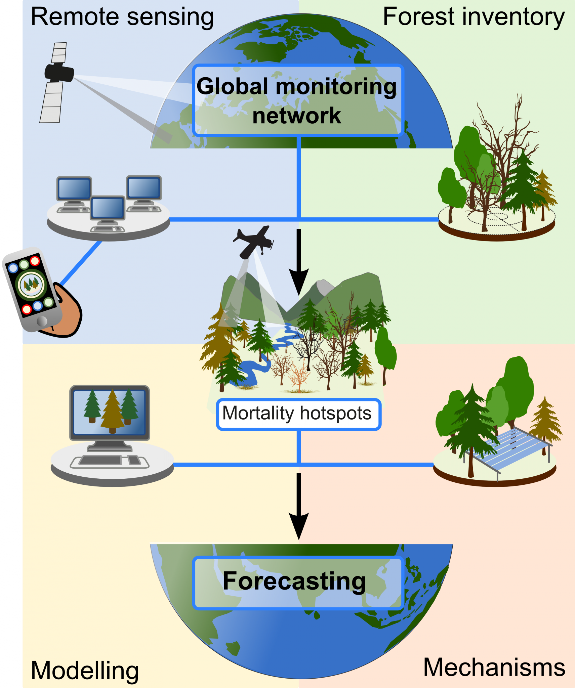
Information at the scales, needed to link plot data to remote sensing pixels, constitutes a major gap, especially with respect to detecting and attributing altered rates of tree mortality. Repeated LiDAR surveys from aircraft provide high resolution maps of biomass dynamics at this intermediate scale²¹⁻²⁵ and are useful for ground-truthing of larger scale satellite imagery²¹. Airborne LiDAR imagery produces such detailed information that individual trees can be recognised and tracked over time²⁶, allowing large-tree mortality to be tracked in forests. As a last step, verification of remote-sensing data with information with plot networks, like ICP Forests, RAINFOR or national forestry inventories (recently brought together by the GFCP and others), will substantiate global forest condition assessments and allows detection of mortality events and changes in mortality rates (Fig. 1). However, gaps in the vertical flow of information, across spatial scales and data types, can be efficiently filled if data sources are shared and made freely available to the scientific community and shared efforts are undertaken²⁷.

Fig. 1 Strategy for a global assessment of forest condition. An integrated multidisciplinary global monitoring network quantifies background tree mortality and patterns and trends in forest stressors as well as substantial tree mortality, based on satellite data, Lidar cruises, and merged data sources including forest inventories, research plots and citizen science. The mortality hotspots can guide the siting of intensive field observations and experiments to establish improved mechanistic relationships in vegetation models for more realistic projections of future forest conditions.

Task force activities
We propose an initiative including four main elements: (1) retrospective knowledge (gap) analyses, (2) foster the interdisciplinary and international collaboration in understanding tree mortality, (3) collaborative compilation and analyses using existing data and research infrastructures, and (4) developing a guideline to monitor forest mortality events at different scales and summarise the findings in a conceptual framework .
Within the first period (2017-2019) we aim to:
- Synthesize knowledge and identify information gaps on mortality processes at regional, continental, and global scales. This shall include regions that are rarely found high up on the international forest research agenda (for example, Central Asia and Oceania South America)
  - Five continental/regional workshops (Europe, Asia, South America, North America, Australia/NZ/Oceania)
Deliverables: Continental and/or zonal ‘state-of-knowledge’ reviews (volumes, paper) as well as global overview on mortality variation among climactic zones and continents. Identification of key stake-holders with substantial forest data and expertise within each region.
Potential: Public symposium connected to a policy meeting (e.g. COP conferences)
Timeline: 2017 to 2019

- Foster interdisciplinary and international collaboration to accelerate documentation and understanding of forest mortality events.
- Two international interdisciplinary workshops on tree mortality, with representatives from remote sensing, forest inventory, forest ecology, vegetation modelers and ecophysiologists (including forest pathologists). The workshops will aim to improve real-time forest assessment tools (e.g., Global Forest Watch) to identify diffuse tree mortality in broad-scale remote-sensing approaches. Moreover, collaborations with already-existing networks of forest inventories and plot networks (e.g., Global Forest Biodiversity Initiative) will provide ground-truthing evidence for diffuse mortality events. In addition, a working group meeting will discuss improvements of inventory protocols by identifying plant traits that can used for stress assessment and for mortality cause attribution. Also bringing people together to use repeat-measures of LiDAR datasets from around the world to work on individual tree mortality;
Deliverables: Exploration on options for new layer within the Global Forest Watch for diffuse tree mortality (acknowledging the lack of global active sensor technologies; a scientific paper on global trends in tree mortality, targeting top-tier journals;
Timeline: 2017 to 2019
Continuation period (2019-2021)

Collaborative compilation and analyses using existing data and research infrastructures
  - Compilation of published data on forest health and mortality from various data infrastructures for meta-analyses, storage in a central open database;
Deliverables: Open database on existing published data on forest health, meta-analysis papers demonstrating the benefit of transdisciplinary collaborative analyses
Timeline: 2019 to 2021

Develop guidelines to initiate and institutionalize a Global Forest Health Monitoring Program to monitor and model forest stress and tree mortality events at different scales, and summarize the findings in a conceptual framework.
  - Compilation and integration of diverse existing methods and data (from continental-scale remote sensing to plot-scale forest inventories) and applications to readily involve field foresters and “citizen science” in data collection.
Deliverables: Thoroughly-developed guidelines and a proposed framework to operationalize and institutionalize a functional Global Forest Health Monitoring Program; web- and mobile application(s) to support international inclusion of field foresters and citizens into forest health data collection; press coverage to inform the public on forest health issues and results in their regions, in their language.
Timeline: 2019 to 2021

Contribution to the implementation of the IUFRO 2015-2019 strategy
Our proposed task force interlinks different research themes within the IUFRO 2015-2019 strategy “Interconnecting forests, science and people”, and thus supports the aim to implement science collaboration. The themes (2) Forest and Climate Change and (4) Biodiversity, Ecosystem Services and Biological Invasions are directly addressed by the task force concept. A focus, however, shall also be on the theme (1) Forests and People due to the inclusion of social aspects and the integration of citizen science. The group work comprises interdisciplinary research and monitoring activities in the fields of Forest Ecology, Ecophysiology, Forest Monitoring and Forest Pathology, Remote Sensing, and Anthropology. Thus, the topic expands perfectly the cross-divisional collaboration within IUFRO. Today’s challenge is to secure forest vitality and productivity for the livelihood and recreation of people but also to maintain stable forest ecosystems for wood products and climate mitigation. Therefore, the task force activity provides a perfect basis for both transdisciplinary research and political consultancy for a very relevant topic and we recommend highlighting the IUFRO involvement and attention by establishing the proposed task force.
Furthermore, we seek to achieve (1) Research Excellence, thrive to actively promote (2) Network Cooperation, and provide (3) Policy Impact.

Open group character and collaborative activities
This TF shall focus on scientific activities, and the group is open to new partners/contributors within IUFRO or outside. Thus, the current group of applicants is the starting team that shall actively seek collaborations with other people during the ongoing activities. We are planning collaborations and networking with other scientific and political organisations (e.g., Global Forest Biodiversity Initiative), networks and groups within IUFRO and outside. We already have a close contact with participants of the ongoing IUFRO TF Forest Adaptation and Restoration under Global Change (namely Ute Sass-Klaasen, Thomas Hickler and Peter Spathelf) and there are common interests with several sub-divisions of the IUFRO divisions 4 Forest assessment and monitoring and 7 Forest health.
These sub-divisions are:
4.02.07 – Large scale forest inventory and scenario modelling (Gert Jan Nabuurs, he is also member of the Global Forest Biodiversity Initiative); 4.02.03 – Forest inventory on successive occasions (Bianca Eskelson); 4.02.05 – Remote sensing (Tomasz Zawila-Niedzwiecki, he was also involved in a publication from the Global Forest Biodiversity Initiative featured on the IUFRO web pages); 7.01.01 – Detection and monitoring (of Impacts of air pollution and climate change on forest ecosystems, Algirdas Augustaitis); 7.01.07 – Multiple stressors on ecosystems (Mikhail Kozlov) as well as E1 – Supersites for Superior Forest Science (Rainer Matyssek) and E8 - Model projections of forest health under climate change
(Christopher Reyer);

Responsibilities and roles within the TF group
The TF coordinator is mainly responsible for the implementation of the concepts and planning the TF activities. This includes the communication among partners and reporting to the IUFRO secretariat, president and involved division coordinators as well as the support in finding funding and supporting resources for the TF activities. The TF group members who give advice based on their particular expertise support the coordinator. Other ‘continental key moderators’ who are involved in the organisation of regional/continental workshops and activities will play a special role. Supra-national collaborating organisations or groups are important to provide information to the TF group or in assisting with information dissemination from the TF.

Expertise table

Name | Disciplines | Some selected key publications  (in regard to TF topic)
Andreas Bolte | Stress physiology, tree competition, forest ecology, silviculture, root ecology | Bolte A, Czajkowski T, Cocozza C, et al. (2016) Desiccation and mortality dynamics in seedlings of different European Beech (Fagus sylvatica L.) populations under extreme drought conditions. Front Plant Sci 7:Art. 751, DOI:10.3389/fpls.2016.00751
Cate Macinnis-Ng | Ecophysiology, ecohydrology, plant water relations | O’Brien M, Engelbrecht B, Joswig J, Pereyra G, Schuldt B, Jansen S, Kattge J, Landhäusser S, Levick S, Preisler Y, Väänänen P, Macinnis-Ng C (In press) A synthesis of tree functional traits related to drought-induced mortality in forests across climatic zones. Journal of Applied Ecology.  Macinnis-Ng C, Wyse S, Veale A, Schwendenmann L, Clearwater M (2016) Sap flow of the southern conifer, Agathis australis during wet and dry summers. Trees, 30: 19-33.
Craig D. Allen | Forest ecology, disturbance ecology, landscape ecology, global change | Allen, C.D., + 19 co-authors. 2010. A global overview of drought and heat-induced tree mortality reveals emerging climate change risks for forests. Forest Ecology and Management 259:660-684.  Allen, C.D., D.D. Breshears, and N.G. McDowell. 2015. On underestimation of global vulnerability to tree mortality and forest die-off from hotter drought in the Anthropocene. Ecosphere 6(8):129. Doi.org/10.1890/ES15-00203.1. 55 p.
Hans Juergen Boehmer | Forest ecology, long-term monitoring, dieback, biological invasions, tree population dynamics, disturbance, disaster risk | BOEHMER, H. J., WAGNER, H. H., GERRISH, G.C., JACOBI, J.D. & D. MUELLER-DOMBOIS (2013): Rebuilding after Collapse: Evidence for long-term cohort dynamics in a monodominant tropical rainforest. – Journal of Vegetation Science 24: 639-650. DOI 10.1111/jvs.12000.
Henrik Hartmann | Ecophysiology, tree mortality mechanisms | Trumbore, S., Brando, P., Hartmann, H., 2015. Forest health and global change. Science 349, 814-818.  Hartmann, H., Adams, H.D., Anderegg, W.R.L., Jansen, S., Zeppel, M.J.B., 2015. Research frontiers in drought-induced tree mortality: crossing scales and disciplines. New Phytol. 205, 965-969.
Matt Hansen | Operational monitoring of tree mortality events | Hansen, M., Potapov, P., Margono, B., Stehman, S., Turubanova, S., Tyukavina A. (2014) Response to Comment on “High-resolution global maps of 21st-century forest cover change”, Science, 344, 981
Nadine K. Ruehr | Forest ecology, ecophysiology, modeling, biogeochemistry | N. K. Ruehr, A. Gast, C. Weber, B. Daub and A. Arneth (2016). Water availability as dominant control of heat stress responses in two contrasting tree species. Tree Physiology, 36(2):164–178.  N. K. Ruehr, B. E. Law, D. Quandt, and M. Williams (2014), Effects of heat and drought on carbon and water dynamics in a regenerating semi-arid pine forest: a combined experimental and modeling approach. Biogeosciences, 11:4139–4156.
Stephen Galvin | Dendrochronology, dendroecology, climate change impact, Eco-DRR
Sylvain Delzon | Ecophysiology, evolutionary and functional ecology | Martin‐StPaul, N., Delzon, S., & Cochard, H. (2017). Plant resistance to drought depends on timely stomatal closure. Ecology Letters, 20(11), 1437-1447.  Larter, M., Pfautsch, S., Domec, J. C., Trueba, S., Nagalingum, N., & Delzon, S. (2017). Aridity drove the evolution of extreme embolism resistance and the radiation of conifer genus Callitris. New Phytologist.
Tanja Sanders | Forest monitoring, forest ecology, dendroecology, remote sensing | Sanders, T. G., Heinrich, I., Günther, B., & Beck, W. (2016). Increasing water use efficiency comes at a cost for Norway spruce. Forests, 7(12), 296.  Wilmking, M., Sanders, T. G., Zhang, Y., Kenter, S., Holzkämper, S., & Crittenden, P. D. (2012). Effects of climate, site conditions, and seed quality on recent treeline dynamics in NW Russia: permafrost and lack of reproductive success hamper treeline advance?. Ecosystems, 15(7), 1053-1064.
Ute Sass-Klaassen | Wood anatomy, Tree biology, Dendroecology, Forest ecology | Sass-Klaassen, U., Fonti, P., Cherubini, P., Gričar, J., Robert, E. M. R., Steppe, K., & Bräuning, A. (2016). A tree-centered approach to assess impacts of extreme climatic events on forests. Frontiers in Front. Plant Sci., 21 July 2016 | https://doi.org/10.3389/fpls.2016.01069
William Anderegg | Forest ecology, ecophysiology, modeling, global change | Anderegg, W.R.L., C. Schwalm, F. Biondi, J.J. Camarero, G. Koch, M. Litvak, K. Ogle, J.D. Shaw, E. Shevliakova, A.P. Williams, A. Wolf, E. Ziaco, S. Pacala (2015). Pervasive drought legacies in forest ecosystems and their implications for carbon cycle models. Science. 349: 528-532.  Anderegg, W.R.L., J.A. Hicke, R.A. Fisher, C.D. Allen, J. Aukema, B. Bentz, S. Hood, J.W. Lichstein, A.K. Macalady, N. McDowell, K. Raffa, Y. Pan, A. Sala, J. Shaw, N.L. Stephenson, C. Tague, M. Zeppel (2015). Tree mortality from drought, insects, and their interactions in a changing climate. New Phytologist. 208: 674-683

Budget table

Main activity | Estimated costs | Funding possibilities
1. Synthesize knowledge and identify information gaps on forest mortality processes | 4 workshops with 10,000 $: 40,000 $ | External funding organizations like VW foundation
2. Accelerate interdisciplinary & international collaboration | 2 workshops, funding depending on number of participants | DFG, VW foundation
3. Collaborative compilation and analyses | Global database and staff: 20,000 $ | Thünen Institute of Forest Ecosystems, MPI Jena
4. Develop guidelines to initiate and institutionalize a Global Forest Health Monitoring Program to monitor forest mortality events

References

