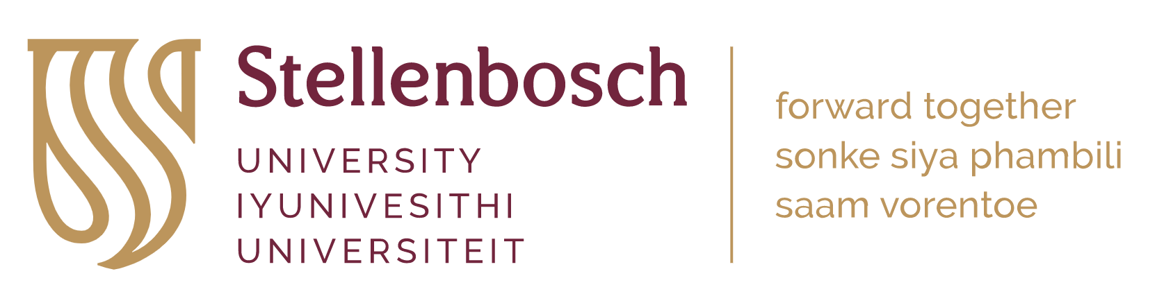

Post-doctoral Fellowship

An individual tree, mechanistic modelling framework for plantation eucalypts

The research project

South Africa has very few long-term, intensively monitored experiments in managed forest environments. Just such an experiment has been implemented as part of the Hans Merensky Chair in Advanced Modelling of Growth and Wood Formation in Eucalypts (EucXylo) at Stellenbosch University. This new experiment, called the IMPACT Open-Air Laboratory (OAL), is located at Somerset West in the Western Cape of South Africa. The experiment focusses on the world’s most widely planted hardwoods: the fascinating genus Eucalyptus, some species of which are the largest flowering plants in the world! See https://eucxylo.sun.ac.za/open-air-lab/ for more information. The focus of this new experimental facility and associated research program is the intensive monitoring of growth and ecophysiology of several eucalypt species experiencing varied levels of between-tree competition. A wide range of sensing equipment are or will be installed at the site, including dendrometers, sap flow sensors and environmental sensors such as soil water probes. The experiment also makes extensive use of remote sensing systems. These systems are implemented across all plots in three replications on an 11-ha site.
This post-doctoral fellowship (PDF) will harness the large amount of data generated from this site, as well as other datasets from prior projects in the EucXylo program and other research programs. The over-arching objective of the PDF will be to develop a new modelling framework, implemented as open-source software, that can be applied to simulate daily individual tree growth. The model must allow individual tree growth to be simulated in a stand context to take into account tree-tree interactions at the IMPACT OAL and in eucalypt plantations in general. Adjustment to a range of existing models (see e.g. models like SurEau; Cochard et al. 2021) will provide an excellent starting point for the work, but development of new models is likely to be needed.

DUTIES
This post-doctoral fellowship will involve:
- Bringing together and modifying existing models, developing new models and integrating models into an overall framework for simulation of growth in individual plantation trees.
- Developing a fully functional open-source software solution that implements the model/s with a practical interface.
- Some data gathering and assistance with site visits (with students or technical staff) at the IMPACT OAL.
- Leading proposal development to bring in additional funds for research activities or travel where possible.
- Co-supervision of at least one student.
- Some assistance with under-graduate teaching in the Department of Forest and Wood Science.
- Publication, as lead author, of at least two peer-reviewed papers reporting findings on the research topic, as well as co-authorship with students also working at IMPACT.

Location
The incumbent will be based full time at Stellenbosch University (SU) in Stellenbosch. SU celebrated its centenary in 2018, is widely acknowledged as one of Africa’s premier tertiary education and research institutions (visit www.sun.ac.za for more information). Staff and students at the University enjoy a relaxed and pleasant lifestyle, close to mountains and sea. Attracting students from around the world, and particularly Africa, and with strong international linkages and collaborations, the DFWS prides itself on research excellence with a diverse, friendly culture.

Requirements and qualifications
- A recognized Ph.D. completed within the last 5 years in an applicable field, but with demonstrable experience in software development/coding in one or more appropriate development languages.
- A sufficient biological background to be able to understand and adapt growth models.
- Up-to-date knowledge in modern scientific data collection, data management, and data/statistical analysis.
- Excellent communication and interpersonal skills to be able to interact effectively with students, scientists, and stakeholders.
- A high level of written and verbal communication skills in English are essential.
- Ability to function in a multicultural and multilingual environment, ability to work well both independently and as part of a team and take initiative.
- A valid South African driver’s license.
- At least one high quality paper already published in the scientific literature.

Recommendations
- Prior experience in working biological time-series data and developing biological models.

Contract duration and commencement
The research stipend is initially granted for a one-year period which will be extended to at least a second year, performance dependent. The base stipend is R350,000 per annum + R10,000 for the purchase of a laptop computer. Although the stipend is fully covered by the project, the successful incumbent will be encouraged to apply for additional top-up funding to expand the scope of the research. All basic running and travel costs will, however, be borne by the project.
Please note that post-doctoral fellows are not appointed as employees in South Africa and their fellowships are awarded tax free, and they are not eligible for standard employee benefits. For more information about post-doctoral fellowships at Stellenbosch visit http://www.sun.ac.za/english/research-innovation/Research-Development/postdocs.
This position is based at the Stellenbosch campus. The incumbent is expected to work full time on campus or at the experimental field site during the workday, although some flexibility in working location can be negotiated.
Commencement: April 2025

Application procedure
Application closing date: End of February 2025
Please send by email to Dr. David Drew (drew@sun.ac.za) the following documents:
- A brief cover letter providing motivation for your application.
- A brief, referenced essay (max two pages, incl. references) in which you explore work previously done in the area of individual tree modelling in eucalypts or other plantation species.
- Current, comprehensive CV with full publication list.
- Copies of doctoral degree certificate and other relevant degree certificates and grades obtained (where applicable).
- Contact details of at least two professional referees.
Any questions about the position can be addressed to Dr. Drew at the same email address. For questions about visas and international relocation to South Africa please contact : Stellenbosch University International HR-IMMIGRATION@sun.ac.za and copy postdocinfo@sun.ac.za.
Applicants who have not received a response within 14 days of the closing date, please accept that your application has not been successful. Short-listed applicants will be contacted to arrange an interview. These candidates may be requested to provide additional information/submissions, and to undergo certain biometric/literacy/other tests.

Cochard, H., Pimont, F., Ruffault, J. et al. SurEau: a mechanistic model of plant water relations under extreme drought. Annals of Forest Science 78, 55 (2021). https://doi.org/10.1007/s13595-021-01067-y

