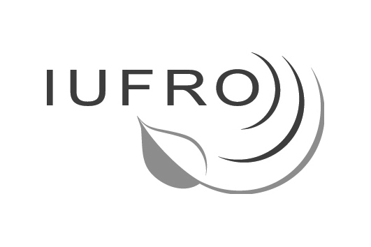
International COuncil meetingS
XXII IUFRO WORLD CONGRESS
9 and 12 August 2005, Brisbane, Australia

DRAFT CONGRESS RESOLUTION
English Version

IC 8/2005 Doc 7.1

Population growth, migration, urbanization and technology changes have transformed the ways in which forests are perceived, managed, conserved and used. Overall, far more is expected of forests now than in the past.

At the same time, the world’s forest cover continues to decline in most regions of the world, and the rate of deforestation remains alarmingly high. Among the short-term consequences of deforestation and forest degradation are biodiversity loss, adverse impacts on the livelihood of people living in and around forests, and reduced local availability of wood and non-wood forest products.

Despite the scientific advances so far, the XXII IUFRO World Congress noted, that the understanding of forest ecosystems evolution and its interface with continuously changing human demands and impacts remains incomplete, and that there continues to be an ample need for scientific knowledge on forests and trees.

Yet, the status and capacities of traditional forest research institutions and universities as well as the funding available to carry out forest research is decreasing in many countries, notably as a result of shifting priorities of policy and decision-makers as well as donors.

It is therefore essential that in the future resource inputs into science and technology are seen primarily as an investment in forest-related socio-economic development and in preserving forests as natural life-support systems for the present and future generations.

It is in our global interest as the forest science community to increase our collaboration across research disciplines and to work together with policy and decision makers as well as stakeholders to find ways to tackle these challenges by means of relevant, scientifically sound information.

To this end the XXII IUFRO World Congress has provided a unique forum for us to present the results of our collective research related to forests and trees and to discuss how research can best contribute to the management, conservation and sustainable development of the world’s forest resources for the benefit of people.

Driven by the wish to further strengthen IUFRO as a home for scientists and research institutions related to forests and trees, including those currently operating outside IUFRO, we will work to:

- provide an improved thematic structure and flexible mechanisms within our organization that allow us to address key issues relevant to forests scientists and their stakeholders and to respond to evolving research questions emerging as a result of the ongoing changes in society;

- continue to make sure that our scientific work lives up to the highest quality standards;

- strengthen the participation of scientists and research institutions of developing countries and countries with economies in transition in the work of IUFRO, including through providing assistance in capacity development of scientists and research institutions;

- promote gender and cultural diversity within IUFRO and increase the participation of young scientists in our organization;

- increase our cooperation with scientists and research institutes working in other scientific disciplines on forest-related research topics that cross the traditional boundaries of forest sciences;

- more actively communicate our research findings within the scientific community and to society at large.

- fully implement the IUFRO Strategy 2006-2010 to position IUFRO as truly global network of forest science knowledge and cooperation.

Also driven by the wish to provide relevant, scientifically sound information and advice to policy and decision makers and other stakeholders, we will work to:

- enhance the provision of relevant problem–oriented forest research to policy and decision makers and other stakeholders and encourage decision makers to make better use of scientific outputs;

- increase efforts to translate research results of the forest science community into unambiguous language that is readily understood by policy makers and other stakeholders;

- further enhance our contributions to the work of international processes and conventions such as the United Nations Forum on Forests, the Convention on Biological Diversity, the United Nations Framework Convention on Climate Change, the United Nations Convention to Combat Desertification, inter alia through the active contribution in the Collaborative Partnership on Forests;

- contribute to the possible establishment of an advisory body to international processes and conventions with the specific purpose of giving scientific advice on forest-related issues similar to the Intergovernmental Panel on Climate Change (IPCC) in climate issues;

- further increase partnerships and collaboration with international organizations and stakeholders;

- contribute to reaching the Millennium Development Goals especially those addressed to reducing extreme poverty and hunger and ensuring environmental sustainability.

