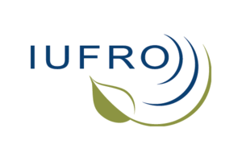
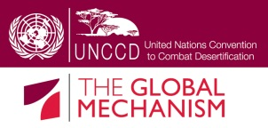
"The Contribution of forests and trees to food security in Drylands"
(Working title)

Side event at UNCCD COP-12 in Ankara, Turkey

Concept note

Co-Organizers:
- IUFRO (Convener)
- Global Mechanism
- FAO

Preferred date:
- October 16th, 13-15 hours

Background and objective:

Forests and trees provide a vital source of food and nutrition to millions of people the world over. Close to one out of every six persons on the planet directly depends on forests, with food being one essential aspect of this dependence. Tree-based systems are particularly critical for food security in drylands, where most of the low-forest cover countries are located.

Yet, there is no single configuration of land uses that can provide all the different outcomes that people may find desirable. In a world characterized by increasing resource and land scarcity, conflicts are likely to arise not just between the most desirable use of the agrarian-forest landscape, but also about how best to accommodate increased demands for land to allow for the expansion of urban settlements, industrial development and resource extraction.

The side event will present the state of knowledge about the contribution of forests and tree-based systems to food security and nutrition by summarizing the key results of the Global Assessment Report prepared by the International Union of Forest Research Organizations (IUFRO) on behalf of the Collaborative Partnership on Forests (CPF) with particular emphasis on drylands. Furthermore, the Food and Agriculture Organizations of the United Nations (FAO) will share their experiences in governance systems that are required to manage trade-offs and promote pathways towards more integrated land uses by highlighting specific examples on the ground.

The presentations will be followed by a moderated discussion on the interlinkages between UNCCD and the sustainable management of forests, trees and landscapes for food security and nutrition.

Key topics:
- Contribution of forests and trees to food security and nutrition in Drylands – Results of the Global Assessment Report on “Forests, Trees and Landscapes for Food Security and Nutrition”;
- Trade-offs, conflicts and synergies in land use for forest and food security;
- Case studies highlighting the contribution of forests and trees to local food security.

Draft programme:

Moderation: Nora Berrahmouni, FAO (representing the Chair of the CPF)

WELCOME
13:15 The Global Forest Expert Panels Initiative and its relevance for the UNCCD (Alexander Buck, IUFRO, Executive Director)
13:20 Sustainable forest management – a key contribution to achieve the objectives of the UNCCD (Sven Walter, Global Mechanism of the UNCCD, Programme Officer)

MAIN CONLCUSIONS OF GLOBAL ASSESSMENT REPORT
13:30 Contribution of forests and tree-based systems to food security and nutrition with particular emphasis on drylands (Professor Bhaskar Vira, University of Cambridge Conservation Research, Director and Chair of the IUFRO-led Global Expert Panel on Forests and Food Security)
13:45 Main drivers affecting forests and tree-based systems for food security and nutrition – Conflicts in and about forests

SYNERGISTIC LAND USE MANAGEMENT FOR FOREST AND FOOD SECURITY
14:00 Intersectoral landscape management – global issues, national experiences (Nora Berrahmouni, Forestry Officer, FAO)

MODERATED DISCUSSION
14:10 Interlinkages between UNCCD and the sustainable management of forests, trees and landscapes for food security and nutrition
14:50 Closure (IUFRO)

