2024 IUFRO Tree Biotechnology Conference Meeting Report
Annapolis, MD, United States

Carsten Külheim, Ying-Chung Jimmy Lin, Sanushka Naidoo, David Kainer, Paula Aguayo

The 2024 IUFRO Tree Biotechnology Conference is the biennial meeting on genomics, molecular biology and biotechnology of forest trees, associated with the IUFRO Working Party 2.04.06. This year’s meeting was held in Annapolis, MD, USA on August 4th to 8th and was hosted by Drs Yiping Qi (University of Maryland), Edward Eisenstein (University of Maryland), Gary Coleman (University of Maryland), and Heather Coleman (Syracuse University). The conference covered seven topics over the course of five days: 1) Biological and ecological insights from OMICS, 2) Advancing technologies for targeted trait manipulation and acceptability to diverse tree species, 3) Genes, development, and physiology, 4) Translating genomics and biotechnology to practice, 5) Trees in a changing world, 6) Genetic and phenotypic diversity for breeding and genomic selection, and 7) Biotechnology for biomaterials and bioeconomy. In addition to the sessions, there were two plenary sessions, provided by John Ralph (University of Wisconsin) and Tanja Pyrhäjärvi (University of Helsinki). The meeting celebrated the second awardees of the newly created IUFRO WG 2.04.06 Award: Excellence in Forest Molecular Biology and Genomics, which was presented to Dr. Chung-Jui (C.J.) Tsai (University of Georgia). Dr. Greg Goralogia (Oregon State University) was the recipient of the associated Early Career Award.
The scientific presentations at the conference highlighted cutting-edge advancements in many facets of forest biotechnology research, including applications of genomic selection in forest genetics and breeding, the use of genetic editing, tree physiology, stress response, molecular breeding, wood development, “omics” technologies, and the social and economic impacts of genetically modified (GM) trees. Scientific take homes from the meeting include the power of NMR to dissect the composition of lignin, the genomic diversity of forest trees that has enourmous potential for tree improvement and integration of systems biology with climate and geographical data.
The conference attracted a mix of students (25), postdoctoral fellows (32), and scientists from academia (66) and industry (18). In all, the conference was attended by 141 registered participants, representing 20 countries that participated in 23 invited lectures (including 6 ‘early-career’ keynotes), 27 voluntary talks and 61 poster presentations. Support for the conference was drawn from a wide variety of Academia, Industry, and Government sources, and included financial support from several tree improvement companies.
Overall, the conference was a great success, providing an exceptional mix of science and social activities in a relaxed and collegial atmosphere. More information about the meeting can be found at https://treebiotech.org/. The next meeting will be held in Stellenbosch, South Africa in 2026, hosted jointly by Zander Myburg, Dave Drew (University of Stellenbosch) and Sanushka Naidoo (University of Pretoria, FABI).
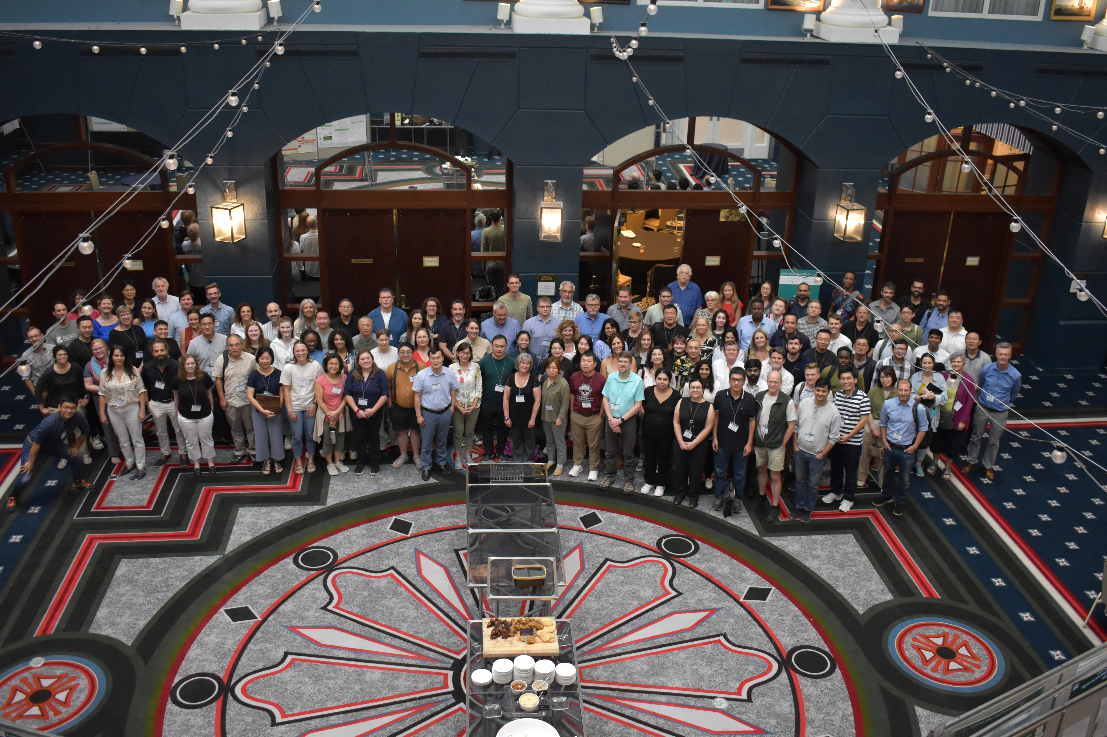
Attendees of the 2024 Tree Biotechnolgy Conference in Annapolis, MD.
Photo provided by Dr. Gen Li

