2022 IUFRO Tree Biotechnology Conference
Online (hosted by Northeast Forestry University and North Carolina State University)
Heather Coleman, Sofía Alejandra Valenzuela Aguila, Jonas Lafave,
Carsten Külheim, Ying-Chung Jimmy Lin
The 2020 IUFRO Tree Biotechnology Conference is the biennial meeting on genomics, molecular biology and biotechnology of forest trees, associate with the IUFRO Working Party 2.04.06 (Molecular Biology of Forest Trees). This year’s meeting was held in online in coordination with the 2nd Forest Tree Molecular Biology and Biotechnology Conference on July 6th to 9th and was hosted by Dr. Vincent Chiang, Dr. Chuanping Yang and Dr. Wei Li (Northeast Forestry University and North Carolina State University). In addition to a robust scientific program, the meeting celebrated the first awardees of the newly created IUFRO WG 2.04.06 Award: Excellence in Forest Molecular Biology and Genomics, which was presented to Dr. Jacqueline Grima-Pettenati. Dr. Jack Wang was the recipient of the associated Early Career Award.

The conference covered five topics over the course of three days: 1) Forestry and Climate Change, 2) Genomes and epigenomes, 3) Wood biology, physiology, development and uses, 4) Genomic variation in breeding and genetic studies, and 5) Regulations and biosafety of GMOs. The scientific presentations at the conference highlighted cutting-edge advancements in many facets of forest biotechnology research, including applications of genomic selection in forest genetics and breeding, tree physiology, stress response, molecular breeding, wood development, “omics” technologies, and the social and economic impacts of genetically modified (GM) trees.
The conference attracted a mix of students, postdoctoral fellows, and scientists from academia and industry. In all, the conference was attended by over ~570 registered participants, representing 36 countries that participated in 72 voluntary talks and over 50 poster presentations. Support for the conference was provided by Northeast Forestry University.
Overall, the conference was a success although all agree we look forward to meeting in person again. More information about the meeting can be found at http://www.treebiotech2022.com/. The next meeting will be held in Annapolis, USA in 2024, hosted by Drs. Yiping Qi and Gary Coleman and colleagues at the University of Maryland.

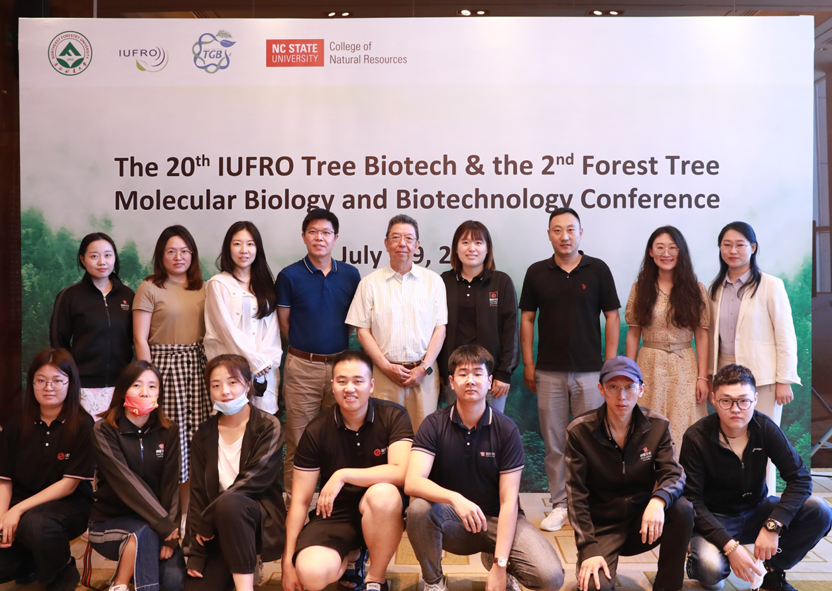
Organizing committee and support team for the 2022 Tree Biotechnology Meeting held online via Northeast Forestry University
Photo provided by Chenguang Zhou

