2019 IUFRO Tree Biotechnology Conference
Raleigh, NC, United States
Heather Coleman, Sofía Alejandra Valenzuela Aguila, Jonas Lafave,
Carsten Külheim, Ying-Chung Jimmy Lin
The 2019 IUFRO Tree Biotechnology Conference is the biennial meeting on genomics, molecular biology and biotechnology of forest trees, associate with the IUFRO Working Party 2.04.06 (Molecular Biology of Forest Trees). This year’s meeting “Forests, Technology and Society” was held in Raleigh, NC, USA on June 23rd to 28th and was hosted by Drs Ross Whetten (North Carolina State University) and Zander Myburg (University of Pretoria). In addition to a robust scientific program, the meeting celebrated the career for Dr. Ron Sederoff, recent awardee of the Marcus Wallenberg Foundation Prize. The conference covered eight topics over the course of five days: 1) Genome structure, function and evolution, 2) Big data in tree genomics and phenomics, 3) Transgenic technologies, genome editing, and in vitro culture, 4) Societal acceptance of tree biotechnology, 5) Genes, development and physiology, 6) Tree responses to climate change, 7) Tree populations, genetics, diversity and breeding, and 8) Biotechnology for biomaterials and bioeconomy. In addition to the sessions, there was a Diversity and Inclusion Breakfast speaking to topics of increasing the participation of underrepresented groups, and there were two panels, one on Biotechnology and Society and one on Diversity and Inclusion.
The scientific presentations at the conference highlighted cutting-edge advancements in many facets of forest biotechnology research, including applications of genomic selection in forest genetics and breeding, tree physiology, stress response, molecular breeding, wood development, “omics” technologies, and the social and economic impacts of genetically modified (GM) trees. Scientific take homes from the meeting include the rise phenotyping as more and more genotyping data becomes available; the advent of collaborative metadata analyses and integration of systems biology with climate and geographical data; and the challenges of genome editing with the understanding of the infinitesimal effect of alleles. Other take homes include the importance of including local indigenous groups in the conversations around forest molecular biology, improving conversations around biotechnology with the public and increasing measures of diversity in our scientific community.
The conference attracted a mix of students, postdoctoral fellows, and scientists from academia and industry. In all, the conference was attended by 160 registered participants, representing 21 countries that participated in 28 invited lectures (including 8 ‘early-career’ keynotes), 28 voluntary talks and over 70 poster presentations with 30 associated lightning talks. Support for the conference was drawn from a wide variety of Academia, Industry, and Government sources, and included financial support from several commercial genomic service providers.
Overall, the conference was a great success, providing an exceptional mix of science, social activities and field excursions in a relaxed and collegial atmosphere. More information about the meeting can be found at https://www.treebiotech2019.org/. The next meeting will be held in Harbin, China in 2021, hosted by Dr. Vincent Chiang and colleagues at the Northeast Forestry University.

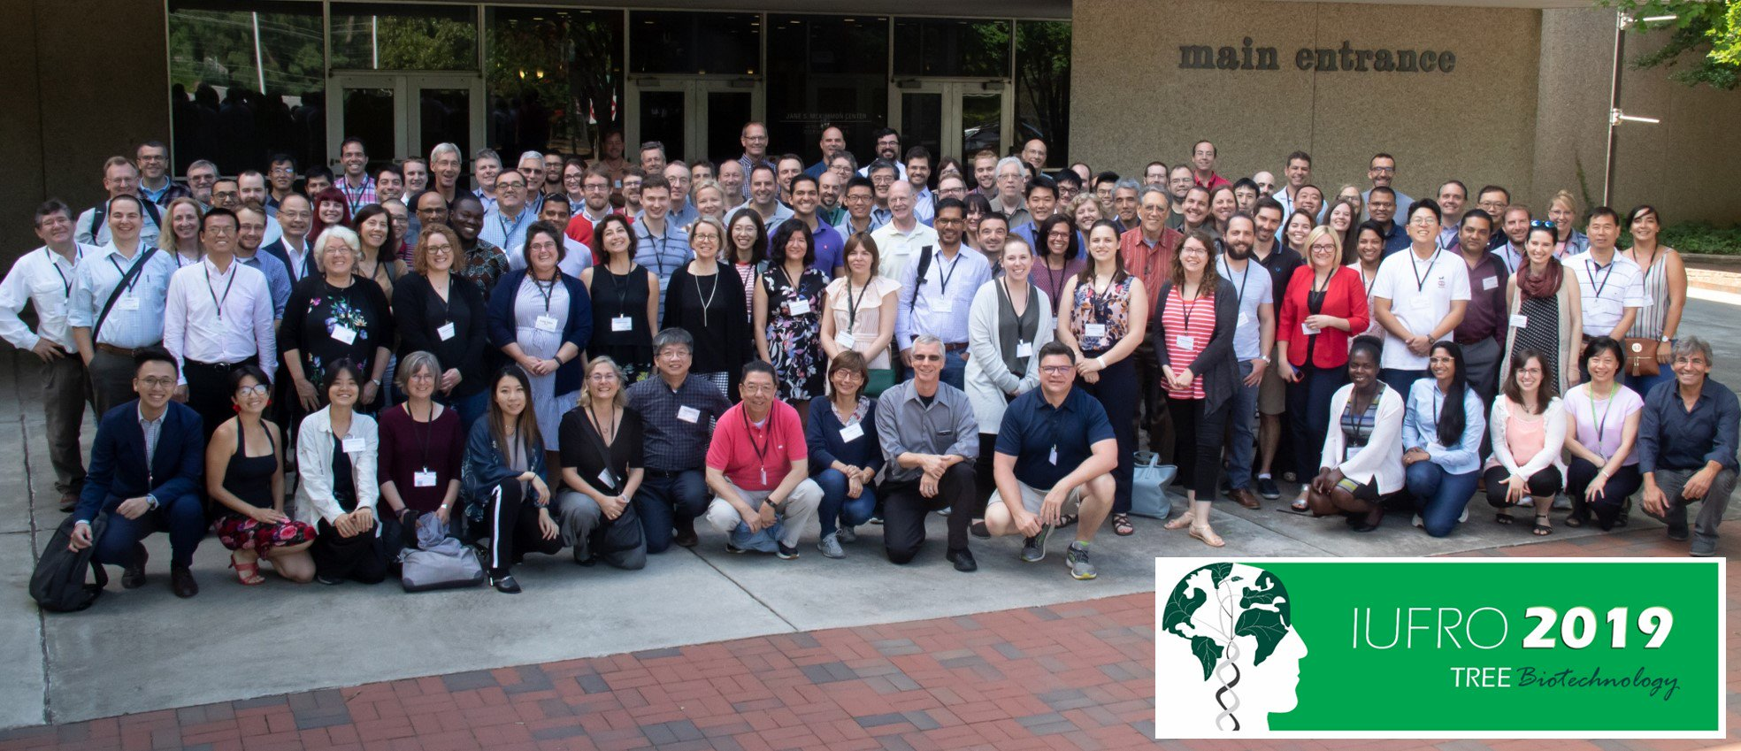
Attendees of the 2019 Tree Biotechnology Meeting in Raleigh, NC
Photo Credit: Frederick Myburg

