Fundamentals of Genomics
Second Annual Training Course Conifer Forest Health Genomics
May 26 – 30 2008
Michael Smith Laboratories, University of British Columbia
Vancouver, British Columbia, Canada
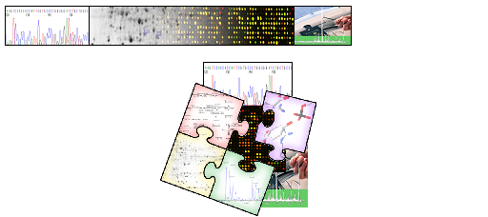

Do you have a desire to learn about leading edge ‘omics’ technologies?

Genomics is a new, fast growing science with potential applications in the biotechnology, genetics and breeding of trees. The molecular technologies utilized in genomics allow the study of integrated biological systems with an astonishing level of sensitivity and throughput never before achieved. To provide an entry-level understanding of this exciting field, the Forestry Genomics project at the University of British Columbia ("Treenomix") will offer a weeklong training course on the basic principles and methods of genomics this summer. To be held at the Michael Smith Laboratories at UBC, it will offer both a theoretical insight and laboratory demonstration, using materials from our ongoing Treenomix project. Upon completion of this workshop, participants should be able to understand and evaluate the value of genomics investigations.

Course overview:
- Five day training course
- Light lunch and snacks provided
- Short excursions to various genomics lab and associated platforms
- Limited enrollment (25)
- Course Fee covered by the Conifer Forest Health Genomics (Genome B.C. and Genome Canada)

Sample topics:
- Introduction to Genome structure
- High throughput DNA sequencing and DNA sequence databases
- Comparative Genomics
- Microarrays
- Proteomic and Metabolomics and Relational databases
- “omic” data integration

For further information and registration, please contact:
Dr. Carol Ritland (604-822-3908 or critland@interchange.ubc.ca)
Dr. Sunita Chowrira (604-822-5508 or chowrira@interchange.ubc.ca)

