IUFRO Meeting Report Form

1) IUFRO focal person/meeting organizer:
Name: Jisen Shi, Professor, Nanjing Forestry University
Function in IUFRO: Deputy Coordinator of Working Party 2.09.01 “Seed Orchards”
Email: jshi@njfu.edu.cn
2) Meeting data:
Full title of the meeting: IUFRO Seed Orchard Conference 2019 – Seed Orchards and Climate Change
Date and venue: 2019 09 14–16, Nanjing International Conference Hotel, Nanjing, China
Meeting website: http://seedorchard2019.njfu.edu.cn/index.html
Number of participants: 206
Countries represented: China, Sweden, Korea Republic, Canada, Czech Republic, Denmark, Poland, Australia, UK, Japan, Russia, Ethiopia
Number of oral presentations: 43 (14 keynote and 29 volunteer)
Number of poster presentations: 12
3) Organization of the meeting:
All IUFRO Units involved: 2.09.01 Seed Orchards (organizing unit), 2.09.03 Seed Physiology and Technology, 2.04.02 Progeny Testing, 2.02.23 Breeding and Genetic Resources of Asian Conifers and 2.02.07 Larch Genetic Resources (participating units)
Host organizations: Nanjing Forestry University (NFU) (primary organizing institution), National Forestry and Grassland Administration (NFGA), Key Laboratory of Forest Genetics and Biotechnology, Co-Innovation Center for Sustainable Forestry in Southern China
Sponsors/Partners: Fujian Provincial Department of Forestry (NFGA), Wuyishan National Park, Yangkou National Forest Farm, Jiangsu Genetic Society (JGS)
Study tour to: Fujian Province: Yangkou National Forest Farm a.k.a “The cradle of Chinese fir breeding”, Southern (Fujian) Chinese Fir Breeding Centre (mass propagation of elite Chinese fir accessions via tissue culture), Guanze Huaqiao National Forest Farm (3rd generation seed orchard of Chinese fir), Wuyishan National Park.
4) Meeting report
The IUFRO Seed Orchard Conference 2019 subtitled “Seed Orchards and Climate Change” was held at Nanjing International Conference Centre in Nanjing, China on October 14–16 2019 as a continuation of activities initiated in 2007 by Professor Dag Lindgren (SLU, Sweden) with the aim of facilitating the exchange of knowledge of forest tree seed orchards as well as promoting new collaborations in seed orchard research. It was the 5th international conference where seed orchards were the main focus, the first being held in 2007 in Umeå, Sweden.
The conference was organized under the auspices of the IUFRO Working Party 2.09.01 “Seed Orchards” and was hosted by Nanjing Forestry University (NFU) in collaboration with National Forestry and Grassland Administration (NFGA), Key Laboratory of Forest Genetics and Biotechnology and Co-Innovation Center for Sustainable Forestry in Southern China. The Chair of the conference was Jisen Shi, Professor of Forest Genetics and Tree Breeding at NFU and Deputy Coordinator of the Seed Orchards WP. To attract scientists, forestry practitioners and students from a broader spectrum of related disciplines, the conference was co-organized with four IUFRO Working Parties: 2.09.03 “Seed Physiology and Technology”, 2.04.02 “Progeny Testing”, 2.02.23 “Breeding and Genetic Resources of Asian Conifers” and 2.02.07 “Larch Genetic Resources.”
The conference covered a broad variety of topics from seed orchard design and management, fertility variation and genetic diversity of seed crops, seed processing and treatment to gene conservation and adaptation of forest trees to changing climate and linking forest tree seed orchards with long-term breeding. Besides, genomic selection and its integration in forest tree improvement programs took up a substantial portion of the conference’s agenda – three of fourteen keynote presentations were dedicated to this topic.
Owing to a number of oral and poster presentations given by Chinese researchers, the conference provided a great opportunity for foreign participants to learn about China’s progress in seed orchards and forest tree improvement. For illustration, China was the World’s leading country in the forest area gain between 2010–2015, with the net gain exceeding 1.5 million hectares per year – an impressive figure that demonstrates China’s commitment to reducing the net carbon dioxide emissions.
Three awards were presented at the Closing Ceremony: Best Oral Presentation by a Young Scientist to Ms. Ye Ji Kim (Seoul National University, Korea Republic); Best Volunteer Award to Mr. Zimou Sun (NFU, China); and Dag Lindgren Award to Prof. Xihuan Shen (Beijing Forestry University, China) in recognition of his contribution to seed orchard research.
The official conference program was followed by a three-day excursion to Fujian province, China’s model province for sustainable development in forestry. The participants were introduced to the Chinese fir breeding program (started in 1958 and currently is in its 4th breeding cycle) and visited Chinese fir progeny and clonal tests, a breeding center for rapid propagation of high-quality Chinese fir seedlings via tissue culture and a 3rd generation seed orchard of Chinese fir that supplies many provinces with high genetic quality seeds, securing up to 50% gains in volume production compared to genetic materials from the 2nd generation. The impressive and highly informative trip was concluded in Wuyishan National Park, a beautiful mountainous area that has been listed as a UNESCO World Heritage Site for its cultural, scenic and biodiversity values.
The conference was a nice blend of science, networking and sightseeing, leading to the establishment of several collaborations among Chinese and foreign scientists.
The next seed orchard conference will take place in Bucharest, Romania and will be hosted by the National Institute for Research and Development in Forestry “Marin Dracea” (https://www.icas.ro/), a public institution that has been certified as an Excellence Center in Forest Biology and Management specializes, among other activities, in national forest inventory and implementation of new technologies towards sustainable forest management in Romania. The contact person is Dr. Georgeta Mihai, Deputy Coordinator of the IUFRO WP 2.09.01 “Seed Orchards”.
4) Photos
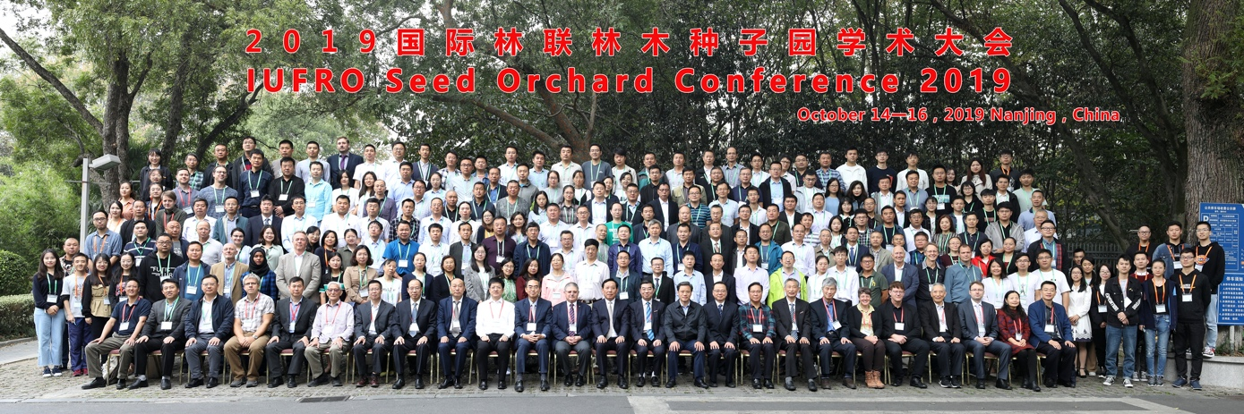
Caption: Group photo, IUFRO Seed Orchard Conference 2019, Nanjing, China (Monday, October 14th, 2019)
Credit (not protected by copyright): IUFRO Seed Orchard Conference 2019, Nanjing, China

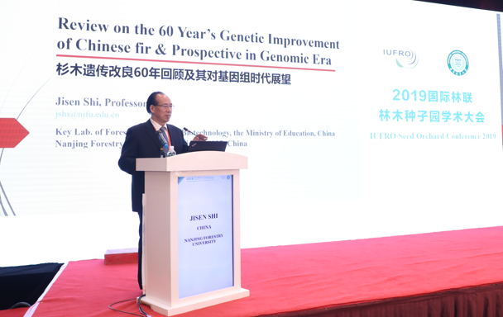
Caption: Keynote presentation by Prof. Jisen Shi (Wednesday, October 16th, 2019)
Credit (not protected by copyright): IUFRO Seed Orchard Conference 2019, Nanjing, China

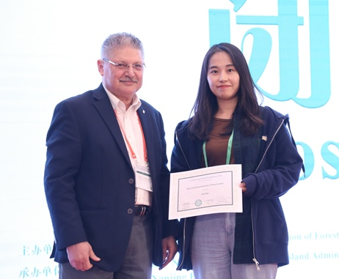
Caption: Best Oral Presentation by Young Scientist presented to Ms. Ye Ji Kim (Seoul National University, Republic of Korea) from Prof. Yousry El-Kassaby (University of British Columbia, Canada) (Wednesday, October 16th, 2019).
Credit (not protected by copyright): IUFRO Seed Orchard Conference 2019, Nanjing, China

Caption: Social trip to downtown Nanjing, area near Confucius Temple (Tuesday, October 15th, 2019).
Credit (not protected by copyright): Tomas Funda
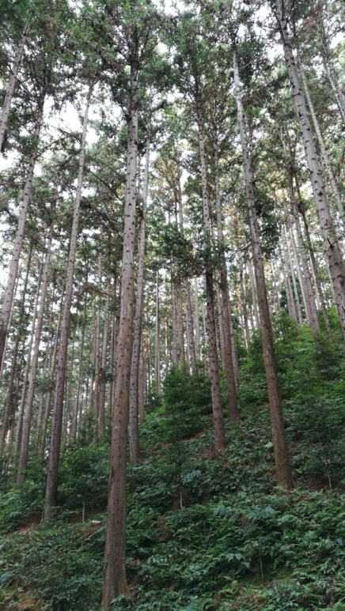
Caption: Progeny test with Chinese fir at Yangkou National Forest Farm, Fujian Province, China (Thursday, October 17th, 2019).
Credit (not protected by copyright): Tomas Funda
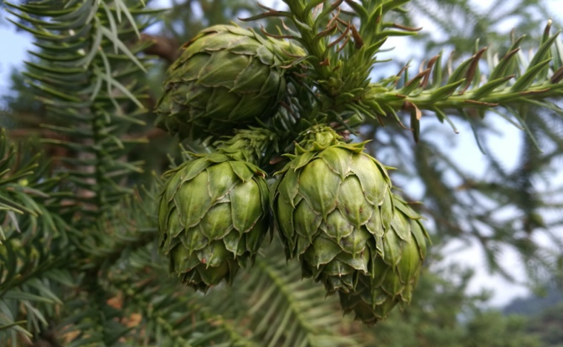
Caption: Female cones in 3rd generation seed orchard of Chinese fir at Guanze Huaqiao National Forest Farm, Fujian Province, China (Friday, October 18th, 2019).
Credit (not protected by copyright): Tomas Funda
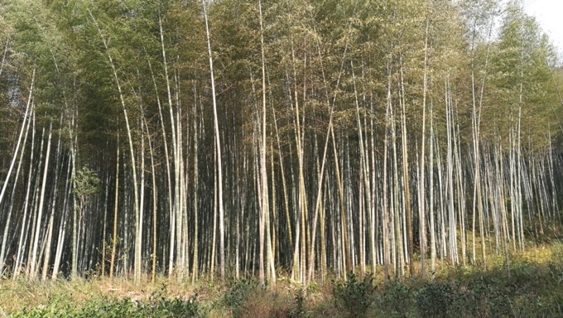
Caption: Bamboo forest in Wuyi Mountain National Park, Fujian Province, China (Friday, October 18th, 2019).
Credit (not protected by copyright): Tomas Funda

Caption: Wuyi Mountain National Park, Fujian Province, China (Friday, October 18th, 2019).
Credit (not protected by copyright): Tomas Funda

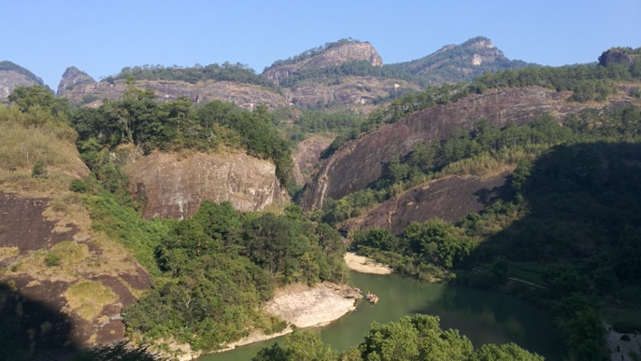
Caption: Hike to Tianyou Peak, Wyuishan, Fujian Province, China (Saturday, October 19th, 2019).
Credit (not protected by copyright): Tomas Funda
5) Other information:
As part of the Opening Ceremony on Monday, October 14th, Dr. Kyu-Suk Kang (Seoul National University, Korea Republic) and former Coordinator of IUFRO Seed Orchards WP gave a presentation about IUFRO’s structure and goals with emphasis put on tasks and activities concerning Division 2 “Physiology and Genetics.”
Conference Proceedings are being compiled by the organizers and will be accessible online on the conference website at http://seedorchard2019.njfu.edu.cn/index.html.

Prepared by: Dr. Tomas Funda, SLU Sweden, Coordinator of IUFRO WP 2.09.01 “Seed Orchards”

