**IUFRO Meeting Report Form**

Organizers of IUFRO meetings and IUFRO focal persons at IUFRO co-sponsored meetings, respectively, are kindly requested to fill in and return this form within two weeks after the meeting or by a given deadline by email (wolfrum@iufro.org). This information will be posted at the relevant IUFRO web pages and may be used for IUFRO News and the IUFRO Annual Report.

*(Note: Save this file under a new name and write directly into the form.)*

**1) IUFRO focal person/meeting organizer:**

*Name: Muedanyi Ramantswana*

*Function in IUFRO: Symposium*

*Email: [Muedanyir@mandela.ac.za](mailto:Muedanyir@mandela.ac.za)*

**2) Meeting data:**

*Full title of the meeting: Modern Silviculture Symposium, Silviculture 4.0, “theme Smart technology from nursery to field“*

*Date and venue*: 15th to 17th October 2024, Oasis Church Auditorium in Howick, KwaZulu-Natal, South Africa

*Meeting website:* [*https://www.modernsilviculturesymposium.co.za/*](https://www.modernsilviculturesymposium.co.za/)

*Number of participants: 200*

*Countries represented*: South Africa, Brazil, Denmark, ESwatini, Kenya, New Zealand, Sweden, Uruguay

**3) Organization of the meeting:**

*All IUFRO Units involved*: Division 3 -3.01.00 and 3.02.00

*Host organization(s)*: Nelson Mandela University, Ellepot,

Sponsors (s): Ellepot, ISO Horti Innovators, Forsilvitech, Novelquip Forestry, Stihl, Bracke Forest, IUFRO

*Study tour(s) to: Silviculture operations and demonstrations (Mondi, Tetworth plantation) and Forestry Nursery (Sappi Clan Nursery) in KwaZulu-Natal*

**4) Meeting report** *(max. 100 words per paragraph)*

*a) Background information (meeting context)*

The Silviculture 4.0 Symposium focused on the application of smart technology in forestry, from nurseries to field operations. Organized by Nelson Mandela University and Ellepot, the symposium provided a platform for industry stakeholders to explore digitalization, automation, robotics, and big data in modern silviculture. The follow key themes were presented and discussed at the symposium over two days followed by a field day which comprised of various silviculture technology demonstrations.

*b) Key issues discussed/latest findings in the field (bullet points or text)*

*Symposium day 1*

* Advances in mechanized and automated nursery operations (e.g., robotic systems, RFID tagging).
* Environmental sustainability through the adoption of biodegradable planting materials and smart irrigation systems.
* The importance of genetic improvement and bioproduct development for better forest management, highlighted by Suzano (Brazil) in integrating research with operational efficiency​
* Automation and AI-driven solutions for nursery efficiency, such as the FlexSorter and CuttingEdge platforms introduced by TTA (Netherlands) to address seed quality issues and labor shortages​.
* Role of water conservation and advanced irrigation management in nurseries, as presented by Ellepot (South Africa) focusing on optimizing irrigation to enhance seedling growth and reduce environmental impact​.
* Integration of sustainable practices in nursery operations, including air-pruning and eco-friendly materials, to reduce environmental footprints and enhance seedling survival globally. The shift towards containerized nursery stock for improved mechanized planting efficiency, with case studies from Kaingaroa Timberlands (New Zealand) demonstrating the benefits of paper pots in planting systems​.
* Robotic systems for cuttings and plant handling, as presented by ISO Group (Netherlands), which automate labor-intensive processes such as cutting, planting, and grading in nurseries​.

Symposium day 2

* The strategic pillars to consider when modernizing silviculture operations accordingly to Mondi
* Use of real-time telemetry and AI-driven tools to manage mechanized operations and improve efficiency, as demonstrated by Dexco (Brazil) for pest detection and forest quality assessment​
* Forecast of future silviculture technologies based on machine related, material inputs, operater related and digitalization innovations, research by Nelson Mandela University
* Emphasis on socioeconomic upliftment in forestry-dependent communities, balancing mechanization and labor retention, discussed by DFFE (South Africa)​.
* Data-driven technologies for forest monitoring, including satellite imagery, drones, and IoT sensors, enabling enhanced pest and disease detection across large forestry areas globally​.
* The role of digitalization and automation in forest regeneration, showcased by Skogforsk (Sweden) with autonomous planting machines and teleoperated soil scarification​ machine
* Advances in herbicide application methods using drones and remotely piloted aircraft systems (RPAS) for precision in pre-canopy weeding, highlighted by PACSys (South Africa).
* Benefits of mulching for fire management and soil conservation, including increased water retention and enhanced tree growth, discussed by Sappi (South Africa)​.
* Improvements in seedling survival and quality using advanced substrates and controlled environments, presented by Ellepot (South Africa), focusing on enhancing root development and resilience.
* Mechanization in steep terrain operations using advanced planting technologies like the Bracke planters (P11 and P12) from Bracke Forest (Sweden).
* Spot cultivation techniques for high-precision planting, showcased by Novelquip Forestry (South Africa) through their advanced mechanized planter.
* Precision forestry operations, such as AI-enabled drones and satellite-based pest detection systems, showcased by CROPWATCH AFRICA (BIOSYNTRIX) (South Africa), enabling forest managers to make data-driven decisions on pest management​.
* Mechanization of pre-canopy weeding using advanced boom sprayers and AI tools to apply herbicides with higher precision, as adopted by Mondi (South Africa) to reduce labor costs and improve productivity​.
* Productivity comparison of manual versus semi-mechanized planting methods and planting quality, research form Nelson Mandela University
* Comparison of pitting machine operations and work quality, research presented by Nelson Mandela University
* Fire risk management strategies, including the combined use of slash burning and disc harrowing to reduce fuel loads and maintain soil health, researched by Stellenbosch University (South Africa)​.

***c) Conclusions (if possible, summarize key conclusions across presentations):***

The Silviculture 4.0 Symposium highlighted that modernizing silviculture operations is critical for addressing labor shortages, improving productivity, and promoting sustainability. Across the presentations, it was evident that mechanization and automation are transforming both nursery and field operations. Automated systems, such as robotic planting and AI-powered nursery technologies, showcased by companies like TTA (Netherlands) and ISO Group (Netherlands), are reducing the reliance on manual labor while improving precision and consistency in forestry processes. Additionally, digital tools such as drones, real-time telemetry, and AI-enabled pest detection systems—demonstrated by CROPWATCH AFRICA (BIOSYNTRIX) (South Africa) and Dexco (Brazil)—are revolutionizing forest monitoring and pest management by enabling early detection of issues and providing critical data for decision-making. Environmental sustainability also emerged as a major focus, with companies like Suzano (Brazil) and Ellepot (South Africa) emphasizing the importance of biodegradable materials, water recycling, and climate-resilient seedlings to reduce the ecological footprint of forestry operations. Mulching, as showcased by Sappi (South Africa), has proven (in some cases) to enhance soil health, improve tree survival, and conserve water, making it a valuable tool in sustainable silviculture. The role of mechanized planting and site preparation technologies, such as those developed by Bracke Forest (Sweden) and Novelquip Forestry (South Africa), was also emphasized, especially in improving productivity on steep and challenging terrains. These technologies not only boost planting efficiency but also improve seedling establishment and survival rates.

Balancing socioeconomic impacts was highlighted, particularly in regions like South Africa where forestry-dependent communities rely heavily on manual labor. DFFE (South Africa) stressed the importance of balancing modernization with job retention, ensuring that mechanization benefits both operational efficiency and local employment. Innovation in herbicide application and pre-canopy weeding is also advancing, with PACSys (South Africa) and Mondi (South Africa) demonstrating how drones and boom sprayers are enhancing accuracy, reducing chemical use, and lowering labor costs. The shift towards containerized stock for more effective planting, particularly in New Zealand and South Africa, was also a key takeaway. Biodegradable paper pots were shown to improve root development and increase survival rates, supporting global sustainability goals. Training and skill development were recognized as essential for successfully adopting new technologies, with companies like Dexco (Brazil) and Mondi (South Africa) emphasizing the need to upskill rural workforces to manage mechanized and digital technologies effectively.

In conclusion, the future of silviculture lies in integrating cutting-edge technology with sustainable practices. The symposium underscored the importance of continuous innovation, collaboration between industry and academia, and the careful management of socioeconomic impacts. These steps are vital to ensuring that the benefits of modernization in silviculture are maximized while minimizing any negative consequences.

***d) Outlook to future activities (proceedings, future meetings, other):***

In future, the annual Modern Silviculture webinars hosted by NMU will continue and the intervals of hosting future physical meetings is yet to be confirmed.

**4) Photos**

*Caption:*

*Credit (not protected by copyright):*

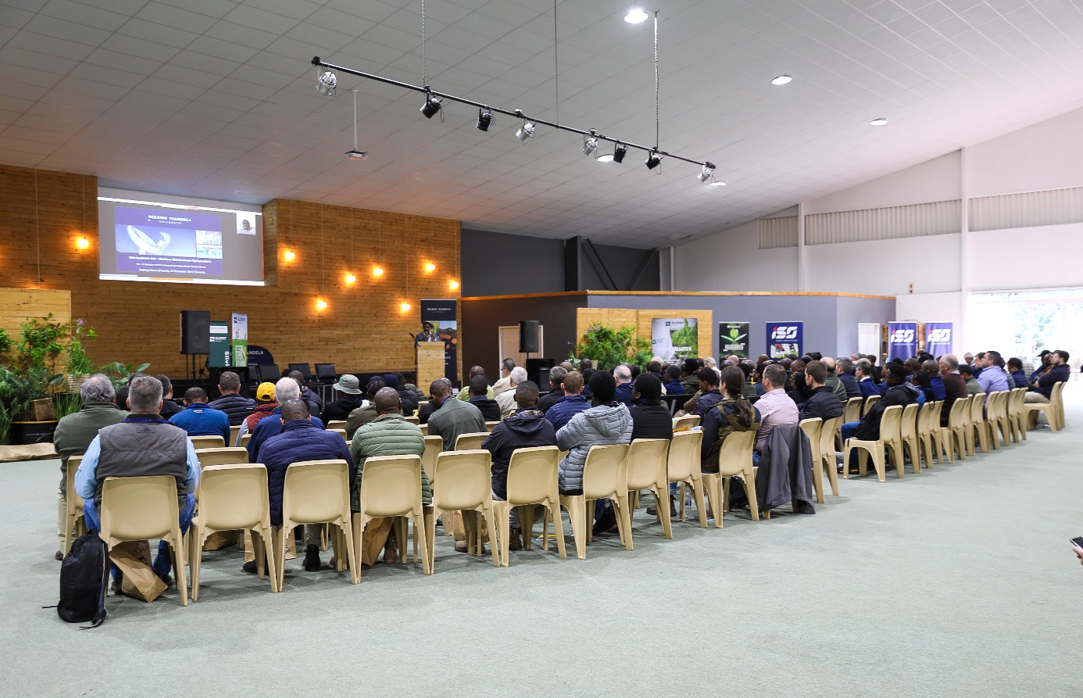

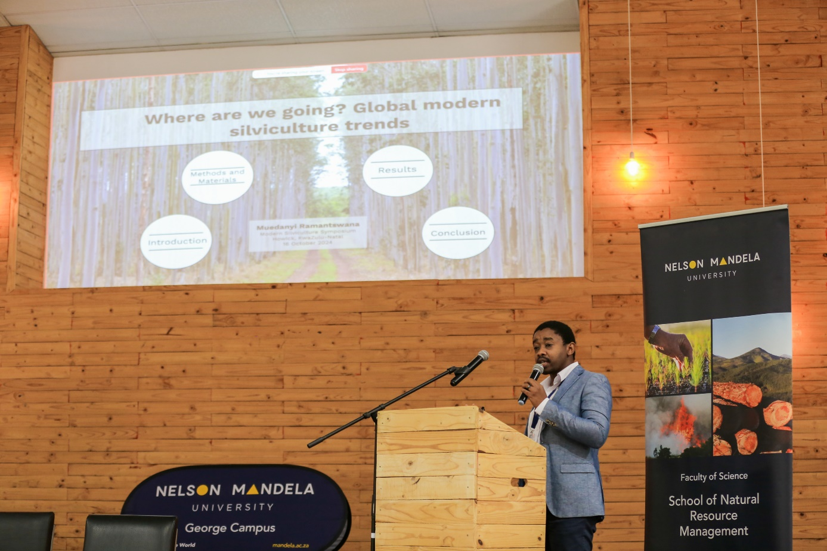

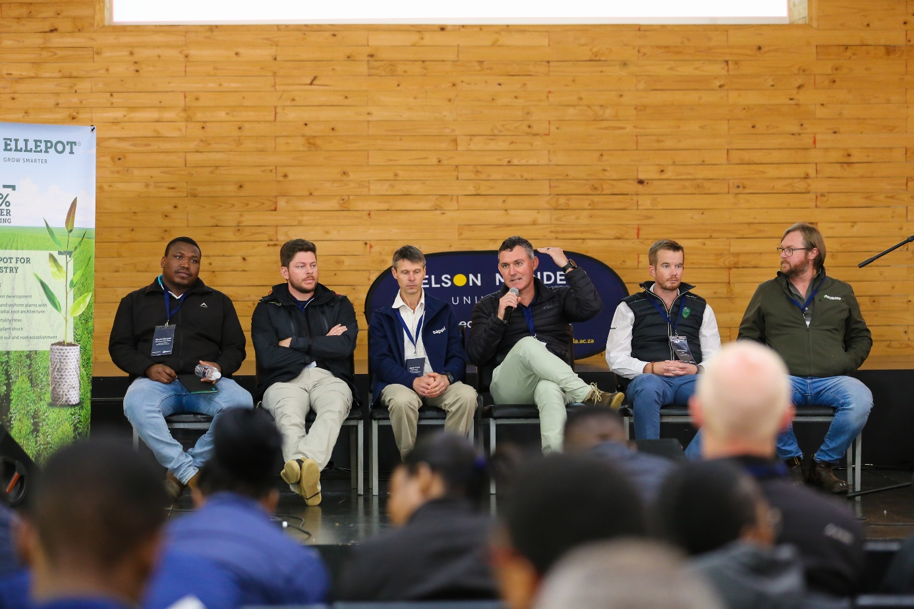

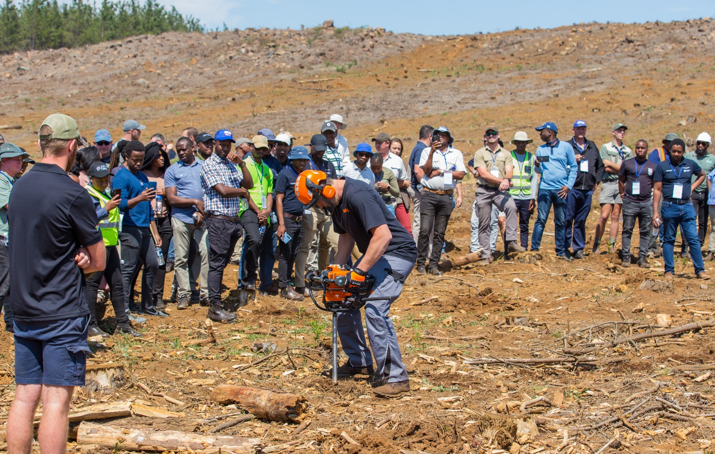

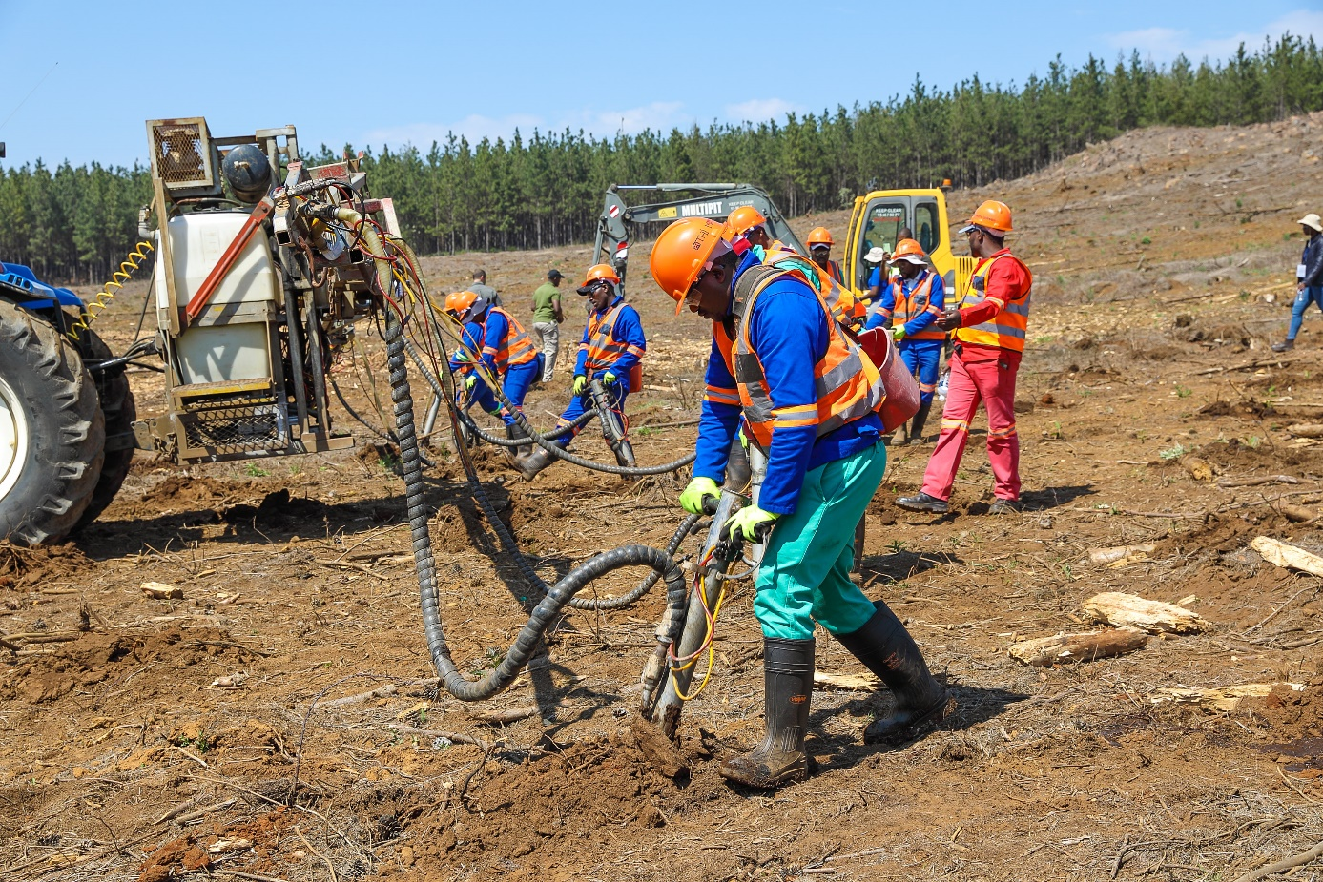

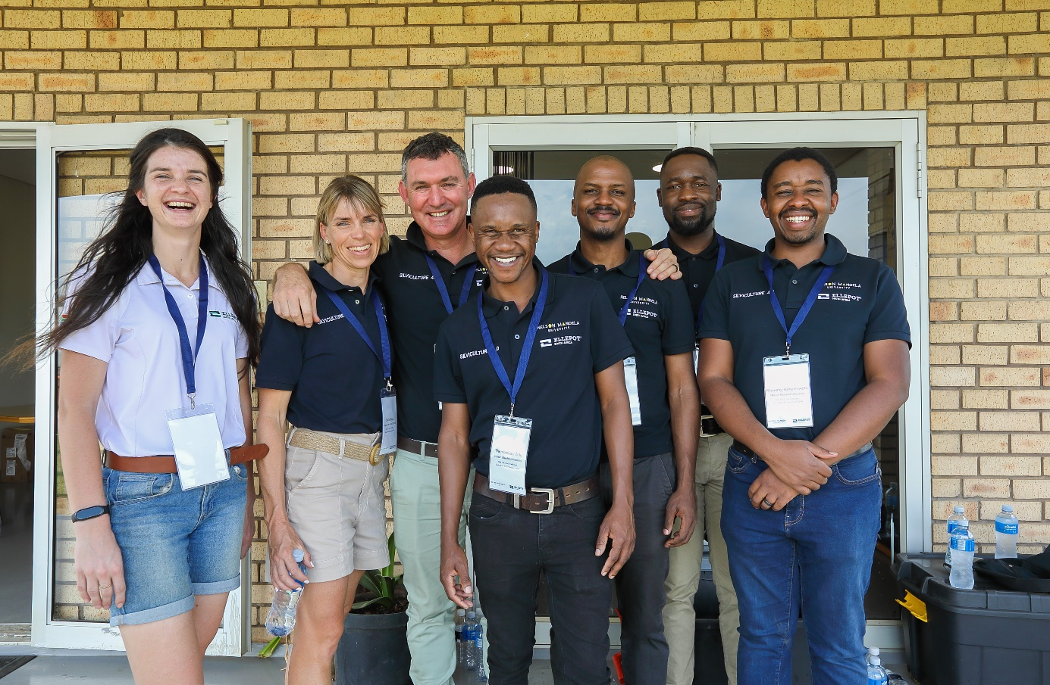

**5) Other information**:

*a) Communication activities (dissemination of information about the meeting; promotion of IUFRO)*

*b) Related publications /websites*

**Thank you very much for your kind cooperation!**