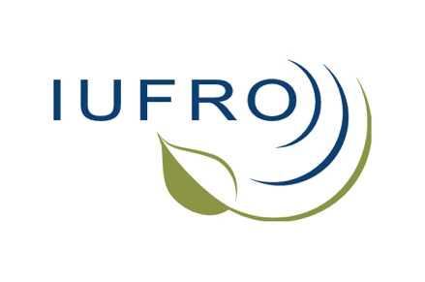
IUFRO Small-scale Forestry/Extension and Knowledge Exchange 2025 Conference

  - First Call for Papers (due 12-Feb-2025)
Submit proposals to Brett Butler (brett.butler2@usda.gov) or
Calvin Norman (cmn5525@psu.edu)

Lead Author
Name:
Affiliation:
Email address:

Co-authors and Affiliations

Presentation Type
Full oral presentation
Speed talk

Abstract
(Maximum 250 words)

