IUFRO Meeting Report Form

Organizers of IUFRO meetings and IUFRO focal persons at IUFRO co-sponsored meetings, respectively, are kindly requested to fill in and return this form within two weeks after the meeting or by a given deadline by email (wolfrum@iufro.org). This information will be posted at the relevant IUFRO web pages and may be used for IUFRO News and the IUFRO Annual Report.

1) IUFRO focal person/meeting organizer:
Name: Manuela Hirschmugl, Alfredo DiFilippo, Miroslav Swoboda
Function in IUFRO: Coordinators of WGs 4.02.05, 1.01.07, 8.01.01
Email: manuela.hirschmugl@joanneum.at, difilippo@unitus.it, svobodam@fld.czu.cz

2) Meeting data:
Full title of the meeting: Characteristics of Ecosystem Services of European Old-Growth Beech Forests

Date and venue: 2 October 2024, Bruges, Belgium
Meeting website: https://lifeprognoses.eu/
Number of participants: 56
Countries represented: Austria, Belgium, Bulgaria, Czech Republic, France, Germany, Italy, Slovenia, Slovakia, Ukraine

3) Organization of the meeting:
All IUFRO Units involved: 4.02.05, 1.01.07, 8.01.01

Host organization(s) and sponsor(s): Sonian Forest Foundation (Belgium), University of Ljubljana (Slovenia), Ministery of Natural Resources and Spatial Planning (Slovenia), INBO - Institute for Nature and Forest Research (Belgium).

Study tour(s) to: Sonian Forest on 3 October 2024

4) Meeting report (max. 100 words per paragraph)
a) Background information (meeting context)
The final conference of the LIFE+ PROGNOSES project brought together leading scientists, policy-makers at the European level, and national experts in the field of forest management and conservation. Based on the insights gained in the PROGNOSES project, we discussed means and methods to implement the EU regulation on the strict protection of all primary and old-growth forests in Europe.
b) Key issues discussed/latest findings in the field (bullet points or text)
- Field measurements across European old-growth forests underpin their high ecosystem value including carbon storage, biodiversity indicators and leisure activities
- Preliminary results show the feasibility of using remote sensing for pre-stratification in order to identify the remaining not-protected old-growth forests of Europe
- Primary and set-aside forests generally provide higher ecosystem services in terms of carbon stock and biodiversity structures than managed ones. However, substantial variability between- and within- ecosystem remains across the forest network as a consequence of differences in fertility, disturbance regime and forest history.
- In terms of carbon stocks, previously managed mature forests set-aside from logging are able to recover the average biomass values comparable to those of primary forests. However, they generally lack the same amount of deadwood, oversized trees and tree-microhabitats and wildlife trees found in primary and long unmanaged forests.

c) Conclusions (if possible, summarize key conclusions across presentations):
- More research is still needed to clearly link biodiversity indicators with biodiversity values.
- Visitors to the UNESCO sites were interviewed and showed a clear preference for unmanaged, primary and old-growth forests. Still, only ⅓ of the visitors was aware of the UNESCO World heritage forest area they visited. Thus, more awareness raising is needed.
At the end of the conference, a debate was organized with different stakeholders on the implementation of the mapping and strict protection of old-growth forests in Europe. Although there is a lot of goodwill and effort from scientists as well as local policy makers and management authorities, identification of relics of old-growth on the local level still remains challenging. Further clarifications and efforts will be needed to reconcile competing interests.

d) Outlook on future activities (proceedings, future meetings, other):
For the remaining project duration, the publication of the generated results in scientific journals are the main next steps. Furthermore, a COST action for further networking and knowledge exchange on Europe’s old-growth beech forests is being prepared. The expansion and application of the results on beech forests to include also other old-growth forests, e.g. boreal forests or forests consisting of other tree species, is a main further line of activity.

4) Photos

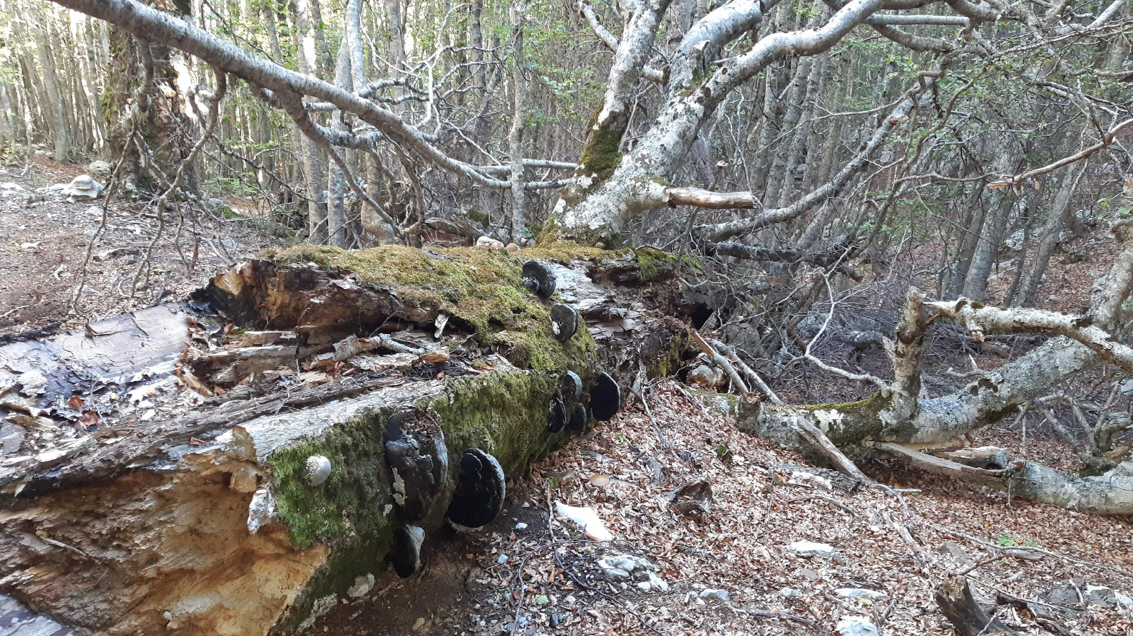
Caption: Lying deadwood in old-growth beech forest
Credit (not protected by copyright): M. Hirschmugl

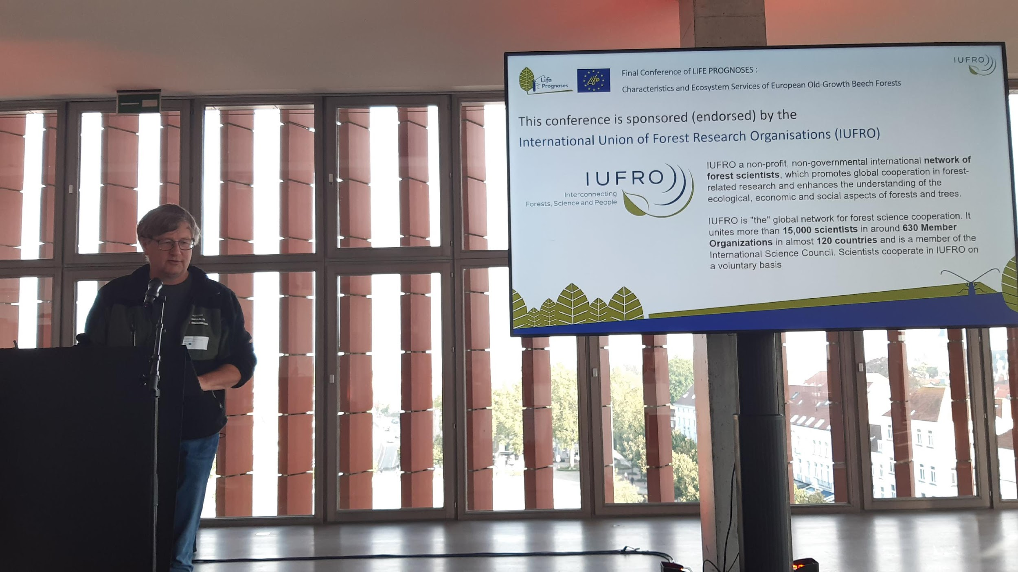
Caption: Kris Vandekerkhove presenting IUFRO
Credit (not protected by copyright): M. Hirschmugl

5) Other information:
a) Communication activities (dissemination of information about the meeting; promotion of IUFRO): presentation at the meeting, IUFRO logo in the invitation and on the agenda/material
b) Related publications /websites: https://lifeprognoses.eu/
Thank you very much for your kind cooperation!

