Headline: Forest ecosystem management decision making methods: an integrated bioeconomic approach to sustainability

Name(s): José G. Borges (Coordinator of IUFRO Unit 4.04.04 and Member of the Conference Committee), Brigite Botequim (Member of the Conference Committee), Barbara Pavani Biju (Member of the Conference Committee) and Harald Vacik (Coordinator of IUFRO Unit 4.03.03).

Summary: The 2021 BIOECOSYS Final Conference (https://www.bioecosys.com/bioecosys-conference) brought together expertise and experience in forest ecosystem management and economics, to communicate recent findings and to accelerate the transfer of knowledge and best practices to stakeholders and forest actors. The main focus of the conference was on a) the communication of innovations in forest ecosystem management and decision support tools as well as in mechanisms to attract payments for ecosystem services and; b) the demonstration of its application to bridge the gap between science and practice.

Background:

The conference built from research and outreach activities by the BIOECOSYS project (https://www.bioecosys.com/, https://www.researchgate.net/project/BIOECOSYS-Forest-ecosystem-management-decision-making-methods-an-integrated-bioeconomic-approach-to-sustainability) targeting scientifically sound methods that can be used for forest ecosystem management by public administrators, non-industrial forest owners, industry and non-governmental organizations. These encompassed (1) criteria and indicators for assessing the impacts of management strategies on biodiversity, vulnerability to wildfires, product and revenue flows and ecosystem sustainability, (2) planning methods that can link traditional stand-level approaches for cork and timber production, with a landscape-level approach that targets spatial structures associated with ecological functioning and the supply of forest-based services, (3) methods that may help assess risk and uncertainty as well as trade-offs between ecosystem services to develop better forest ecosystem management plans, (4) voluntary market mechanisms to match willing sellers (landowners) of forest ecosystem services with willing buyers (e. g. individuals, companies) and, (5) decision support systems as platforms for the transfer of technology and knowledge of forest ecosystems in a way that is understandable to everyone, thus addressing participatory planning concerns. The presentations at the conference benefited from the synergies in research with the MODFIRE (https://www.modfire.net/) and the NOBEL (https://nobel.boku.ac.at/the-project/) projects and was supported by a case study, Vale do Sousa, a forested landscape of about 14 x 10³ ha in Northern Portugal that is jointly managed by over 300 forest owners in Associação Florestal de Vale do Sousa.

In order to increase its effectiveness, the conference was structured into two sessions. In the first session, international keynote speakers provided a global perspective on advanced forest ecosystem management DSS, multiple criteria methods as well as approaches to attract payments for ecosystem services. It was demonstrated that the demands for decision support are emerging from the rising challenges of forest management, considering the adaptation to climate change and the provision of multiple ecosystem services. The second session included presentations of recent research activities targeting the application of forest ecosystem management planning methods, along with business models to implement payments for ecosystem services schemes. It encompassed demonstrations of a Pareto frontier computational platform results to select baskets of ecosystem services and of a web-based platform to support the auction process for different sets of ecosystem services. Both sessions are available in YouTube (https://www.youtube.com/watch?v=Rz1FiIpnqx0). The full video - available in the link above - had a total of 502 visualizations in the first month after being made available.

Participants and Sponsorship: The 2021 BIOECOSYS Final Conference took place on December, 2021 in Lisbon Portugal. It was a hybrid onsite and online event that brought together researchers and stakeholders at very different stages of their careers. It encompassed fourteen presentations and it involved approximately 110 participants (40 in loco and 70 on line) from 42 countries: Albania, Austria, Bangladesh, Bolivia, Brazil, Canada, Cambodia, Ecuador, Ethiopia, Finland, France, Germany, Greece, India, Kazakhstan, Kenya, Latvia, Lithuania, Mexico, Mozambique, Namibia, Nepal, Nigeria, Pakistan, Paraguay, Philippines, Poland, Portugal, Romania, Russia, Slovakia, South Africa, South Korea, Spain, Senegal, Taiwan, Tunisia, Turkey, USA, Uganda, Ukraine and United Kingdom. This conference was funded by the Bioecosys, Modfire and Nobel projects at CEF/ISA and TERRA and was sponsored by the International Union of Forest Research Organizations (IUFRO units 4.04.04; 3.03.03) and ForestWISE, and had Florestas.pt as media partner.

Findings and Future: Academic and non-academic participants were exposed to the evidence of how much forest ecosystem management planning methods and mechanisms can offer to attract payments for ecosystem services, and support policies for sustainable and resilient landscapes. Additionally, the presentations and an eBook with the bstracts will be available soon at the project website and on researchgate

Photographs and figures:

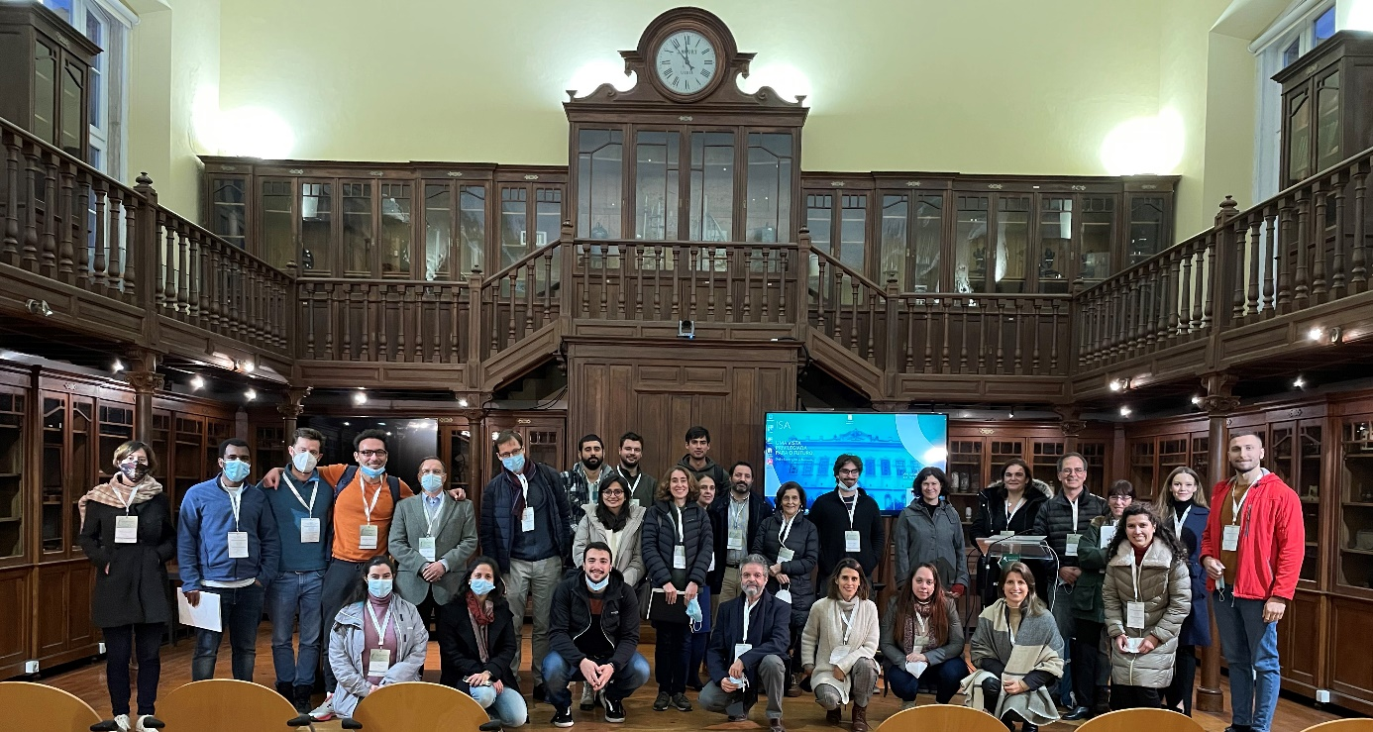
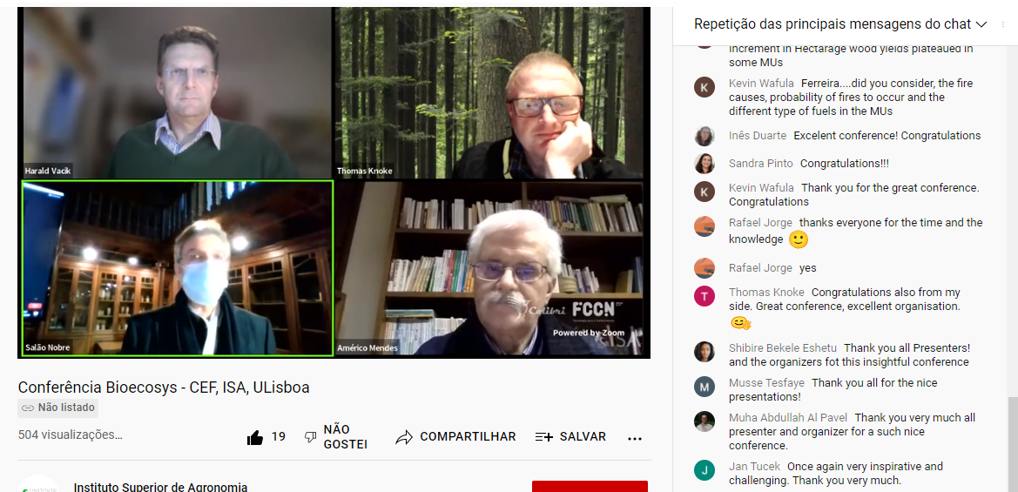
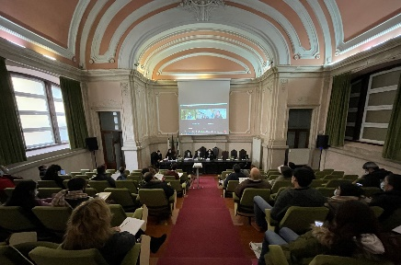

Participants at the 2021 BIOECOSYS Final Conference in Lisbon, Portugal, December 6, 2021 (photos by Márcia Campana and Barbara Pavani, screenshot from the YouTube link above)

