Headline: Systems Analysis in Forest Resources

Names: José G. Borges (Coordinator of IUFRO Unit 4.04.04 and Member of the Symposium Science Committee) and Yu Wei (Chair of the Science and the Organizing Committees).

Summary: The 19th Symposium on System Analysis in Forest Resources (SSAFR) (https://sites.warnercnr.colostate.edu/ssafr2021/ssafr-symposium-of-systems-analyses-in-forest-research/) brought together researchers and practitioners that develop and apply methods of optimization, simulation, management science, and systems analysis to forestry problems. It reported the state-of-the art on the development and use of operations research and system analysis to enhance forest management planning.
Background: The 19th Symposium of System Analysis in Forest Resources was organized by Prof. Yu Wei from the Warner College of Natural Resources of the Colorado State University (CSU) and it was sponsored by IUFRO Unit 4.04.04 as well as by the project DecisionES - Decision Support for the Supply of Ecosystem Services under Global Change and the Department of Forest and Rangeland Stewardship, CSU. This was the 19th Symposium in a series with previous conferences held in 1975, 1985, 1988, 1991, 1994, 1997, 2000, 2003, 2006, 2009 and 2017 in the USA, 1993, 2002, 2011 and 2019 in Chile, 2005 in Brazil, 2013 in Canada and 2015 in Sweden. This series has long provided a) a venue for presentation of state-of-the-art applications of operations research and systems analysis in forest resources management planning and policy analysis, and b) opportunities for a fertile exchange of ideas among forest researchers and practitioners.
The Symposium: The 19th SSAFR took place in July 24-27, 2012 in Estes Park, Colorado, USA. It involved 61 participants from 14 countries in Europe, Africa, America, Oceania and Asia. Its program encompassed 2 keynote presentations by Dr. Mathew Thompson who explored themes of slack and scarcity and how they relate to efficiency and risk in wildfire and by Dr. Jordi Garcia-Gonzalo who presented the European Union H2020 DecisionES project and discussed its strategy to enhance forest management planning and policy analysis by evolving an integrated and multifunctional ecosystem services supply approach. It encompassed further 56 oral presentations organized into 16 sessions focusing on themes such as a) Forest management and planning, b) Forest transportation and supply chain optimization, c) Wildfire risk simulation, management and decision support, d) Forest health, invasive species, and wildlife habitat management, e) Spatially explicit optimization, f) Stochastic process simulation and optimization, g) Quantitative forest and fire economics, h) Forest and watershed management, i) Data science and machine learning, and j) Forest systems analysis under the impact of climate change.

The conference worked well as a meeting place for experts on system analysis in a broad sense. It brought together researchers at very different stages of their careers, from PhD students to researchers taking part in the very beginning of the SSAFR series, and from different continents. The arrangements at the YMCA Rockies in Estes Park was ideal for the conference and the 3 days of scientific work included a much appraised excursion to the Rocky Mountain National Park.

A special issue of the Canadian Journal of Forest Research guest edited by a team lead by Yu Wei (yu.wei@colostate.edu) is underway.

Photographs:

Reception at the 2022 Symposium on System Analysis in Forest Resources in Estes Park, Colorado, USA, July 24-27, 2022 (photo by Jaume Figueras i Jové)
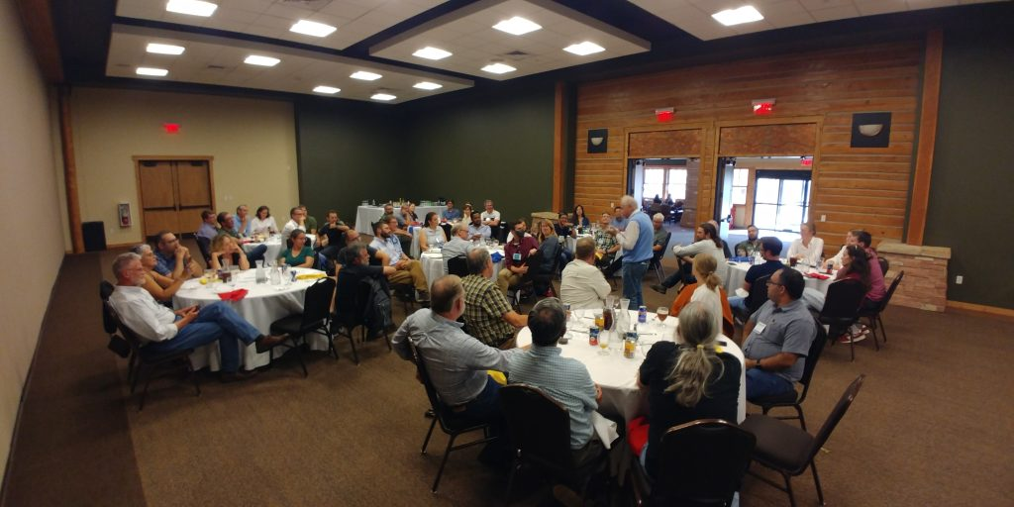

Participants at the 2022 Symposium on System Analysis in Forest Resources in Estes Park, Colorado, USA, July 24-27, 2022 (photo by Kai Bödeker)

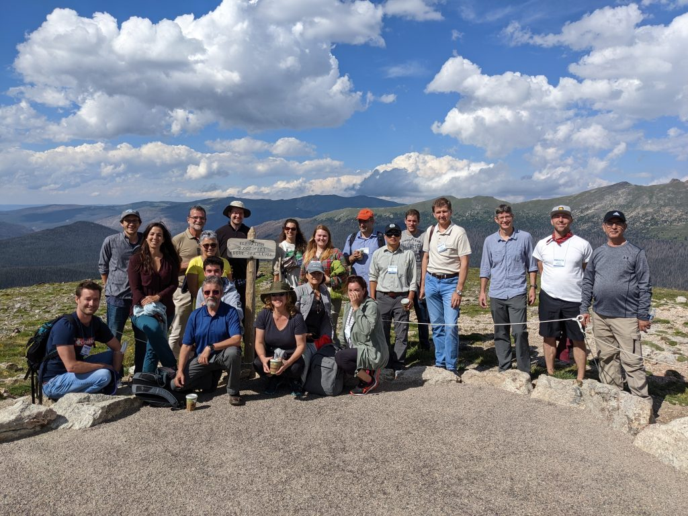
Field trip participants in the Rocky Mountain National Park, USA during the 19th Symposium on System Analysis in Forest Resources on July 26, 2022 ((photo by Kai Bödeker))

