Headline: System Analysis for Sustainable Forest Management and Policy Advice

Name(s): José G. Borges (Coordinator of IUFRO Unit 4.04.04 and Member of the Symposium Scientific Committee), Ljusk-Ola Eriksson (Chair of Symposium Scientific Committee and Member of the Organizing Committee) and Gert Andersson (Chair of the Organizing Committee) and Fredrik Staland.

Summary statement: The 2015 16th Symposium of System Analysis in Forest Resources (http://www.skogforsk.se/english/products-and-events/events/ssafr-20151/) brought together researchers and practitioners that develop and apply methods of optimization, simulation, management science, and systems analysis to forestry problems. It reported the state-of-the art on the development and use of operations research and system analysis to enhance forest management planning and forest policy analysis.

Main Body:

System Analysis in Forest Resources

The 2015 Symposium of System Analysis in Forest Resources took place in August 19-21, 2015 in Uppsala, Sweden. It was organized by the Forestry Research Institute of Sweden (SKogForsk) and the Swedish University of Agricultural Sciences and it was sponsored by IUFRO Unit 4.04.04. This was the 16th Symposium in a series with previous conferences held in 1975, 1985, 1988, 1991, 1994, 1997, 2000, 2003, 2006 and 2009 in the USA, 1993, 2002 and 2011 in Chile, 2005 in Brazil and 2013 in Canada. This series has long provided a) a venue for presentation of state-of-the-art applications of operations research and systems analysis in forest resources management planning and policy analysis, and b) opportunities for a fertile exchange of ideas among forest researchers and practitioners.

The first symposium organized in Europe involved 105 participants from 22 countries in Europe, Africa, America and Asia. Its program encompassed 4 keynote presentations addressing forest resources open problems and current system analysis challenges facing the forest sector. It encompassed further 70 oral presentations and 8 posters organized into 25 sessions focusing on themes such as a) Educational tools in Operations Research/Management Science (OR/MS), b) Multi Criteria Decision Analysis (MCDA) methods, c) Fire and pest - modeling and control, d) Forest Decision Support Systems - construction and use, e) OR/MS techniques for forest planning, f) Forest operations, g) Planning and control systems for the forest-based supply chains, h) The forest-based sector – modeling, i) The forest-based sector – challenges and policies, j) Bioenergy and bio-refineries, k) Transportation & routing and l) Forest management for biodiversity and the environment.

The conference worked well as a meeting place for experts on operations analysis in a broad sense. It brought together researchers at very different stages of their careers, from PhD students to professors taking part in the very beginning of the SSAFR series, and from different continents (this time also a blend of primarily American and European researchers). The arrangements at the Swedish University of Agricultural Sciences campus was ideal for the conference and the 3 days of scientific work was preceded by a much appraised excursion organized by Skogforsk with forest bioenergy at focus. A special issue of the Scandinavian Journal of Forest Research guest edited by Hans Fredrik Hoen at the Norwegian University of Life Sciences (NMBU) is underway.

Photographs and figures:
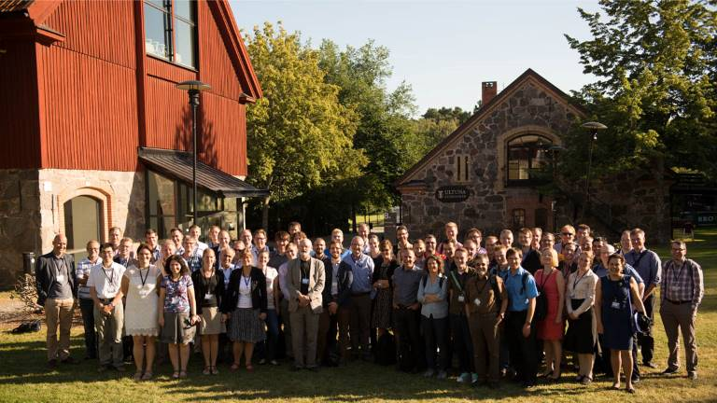
Participants at the 2015 Symposium of System Analysis in Forest Resources in Uppsala, Sweden, August 19-21 (photo by Fredrik Staland)

