IUFRO Meeting Report Form

Organizers of IUFRO meetings and IUFRO focal persons at IUFRO co-sponsored meetings, respectively, are kindly requested to fill in and return this form within two weeks after the meeting or by a given deadline by email (wolfrum@iufro.org). This information will be posted at the relevant IUFRO web pages and may be used for IUFRO News and the IUFRO Annual Report.
(Note: Save this file under a new name and write directly into the form.)

1) IUFRO focal person/meeting organizer:
Name: Yuzou Sano
Chair of Organizing Committee, Hokkaido university of Japan
Email: pirika@agr.hokudai.ac.jp

Name: Hisashi Abe
Vice Chair of Organizing Committee, Deputy Executive Secretary of IAWA, Forestry and Forest Products Research Institute (FFPRI) of Japan
Email: abeq@affrc.go.jp

Name: Yafang Yin
Function in IUFRO: Deputy Coordinator of Division 5 Forest Products, Coordinator of RG. 5.16 Wood Identification, Executive Secretary of IAWA, Chinese Academy of Forestry
Email: yafang@caf.ac.cn

2) Meeting data:
Full title of the meeting: The 10th Pacific Regional Wood Anatomy Conference
Date and venue: September 10–14, Asahikawa, Hokkaido, Japan
Meeting website: https://www.prwac2024.org
Number of participants: 104
Countries represented: Japan, China, Republic of Korea, Slovenia, Thailand, New Zealand, The Philippines, Indonesia, South Africa, The USA and Vietnam

3) Organization of the meeting:
All IUFRO Units involved:
Division 5, RG 5.16, IUFRO-Japan Committee
Host organization(s) and sponsor(s):
Host organization:
- Laboratory of Woody Plant Biology, Research Faculty of Agriculture, Hokkaido university of Japan
Sponsors:
- Asahikawa Tourism and Convention Association
- Forestry and Forest Products Research Institute (FFPRI) of Japan
- IUFRO-Japan Committee
- The Japan Wood Research Society (JWRS)
- Hokkaido Prefectural Government

Study tour(s) to:
- Bogakudai, a nice viewpoint to overview a typical landscape in Hokkaido, Japan
- Forest Products Research Institute, Hokkaido Research Organization, one of the largest institutions for wood products research in Japan.
- CondeHouse Co., Ltd., one of the leading companies for the production of high-quality wooden furniture

4) Meeting report (max. 100 words per paragraph)
a) Background information (meeting context)
The Pacific Regional Wood Anatomy Conference (PRWAC) is an international meeting organized by members of the pacific regional group of the International Association of Wood Anatomists (IAWA). It has been held approximately every four years since the first conference in Tsukuba, 1984, and this was the 10th anniversary. In PRWAC, the participants discuss many topics involving wood science from a viewpoint of ‘wood anatomy’. Desiring countermeasures against the growing climate change in current situation, PRWAC plays an important role for exchanging ideas to use timbers and trees smartly as good carbon stocks.

b) Key issues discussed/latest findings in the field (bullet points or text)
The conference started with a keynote lecture from Dr. Yafang Yin, Executive Secretary of IAWA, providing the history of wood anatomical studies in China in last decades and the latest issues in this field worldwide. In the presentation sessions, a total of 86 presenters talked about their findings on oral or posters. The conference set up three theme sessions about hot topics in wood anatomy and wood science, i.e., application of machine learning to wood science, isotope labelling techniques to clarify elemental processes in wood formation, and cambium activities under the climate change.

c) Conclusions (if possible, summarize key conclusions across presentations):
The participants lively discussed various topics relating wood science such as wood identification, wood utilization, wood formation, tree physiology and ecology and reaffirmed the importance of developing of wood anatomy as a foundation for them. In the conference, interactions among many young researchers and students were remarkable. The organizing committee awarded best presentation prizes to four students after a rigorous selection process, encouraging the next generations. Business meeting of IAWA pacific regional group discussed the further cooperation with international organizations including IUFRO, IAWS, IUBS, IABMS etc.

d) Outlook to future activities (proceedings, future meetings, other):
The abstracts of all presentations in this conference are accessible on the website (http://www.prwac2024.org). The next 11th PRWAC was decided to hold in Hanoi, Vietnam, 2028.

4) Photo
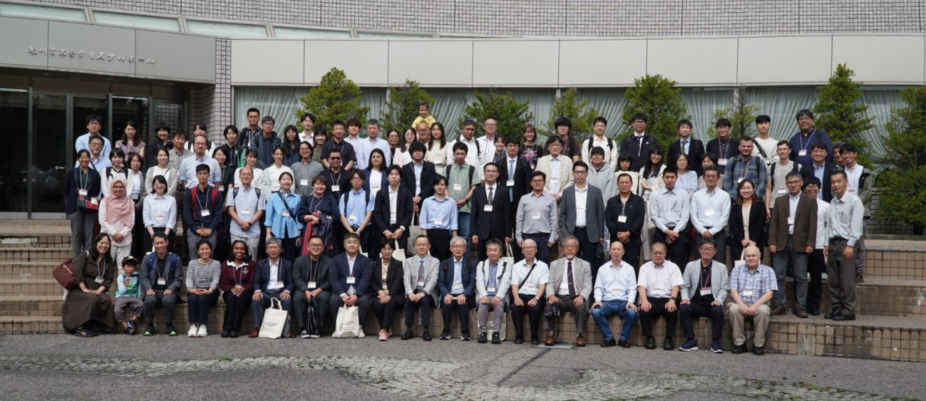

Caption: Group photo of the 10th PRWAC at Asahikawa International Conference Center, 2024
Credit (not protected by copyright): Pictured by Yasuhiro Utsumi, Kyushu University, Japan

5) Other information:
a) Communication activities (dissemination of information about the meeting; promotion of IUFRO)
The information about this conference was disseminated on the website of IAWA and the Japan Wood Research Society.

b) Related publications /websites
Website address of the conference: http://www.prwac2024.org

Thank you very much for your kind cooperation!

