The 2013 International Wood Culture Symposium on Taxodiceae, Central South University of Forestry and Technology, Changsha, China Including Pre-Tours October 22-27, 2013

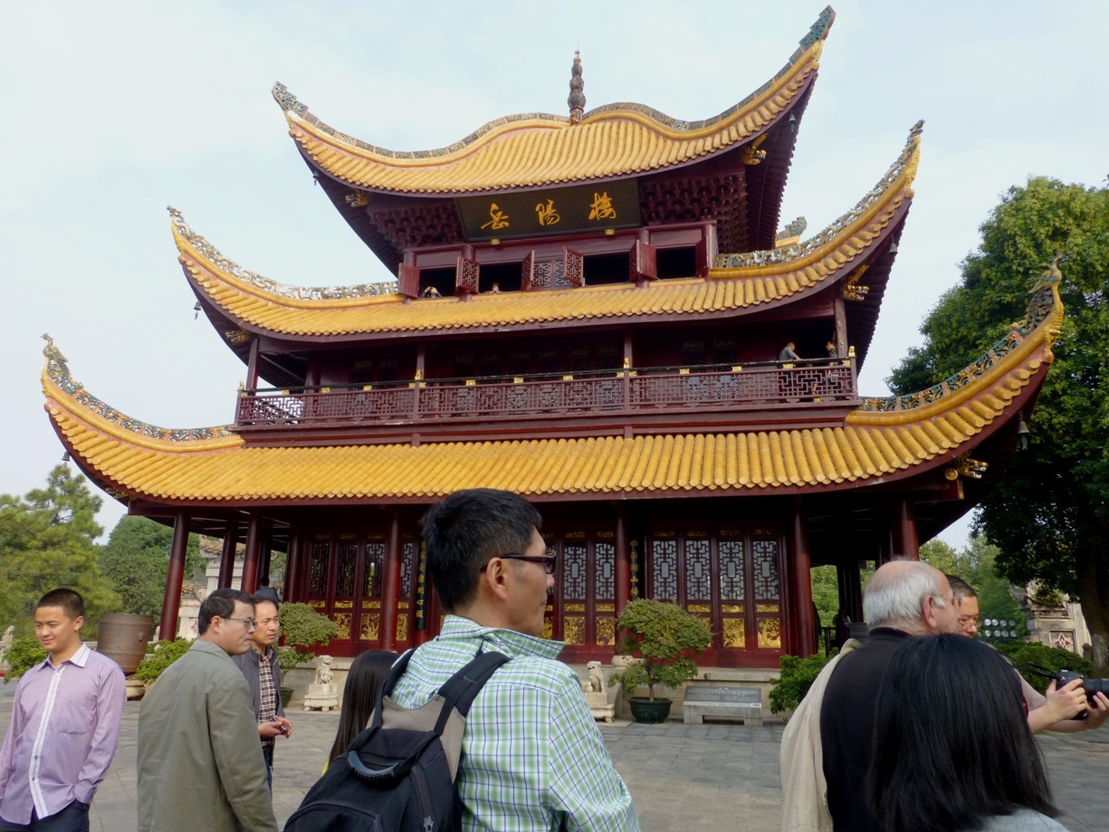
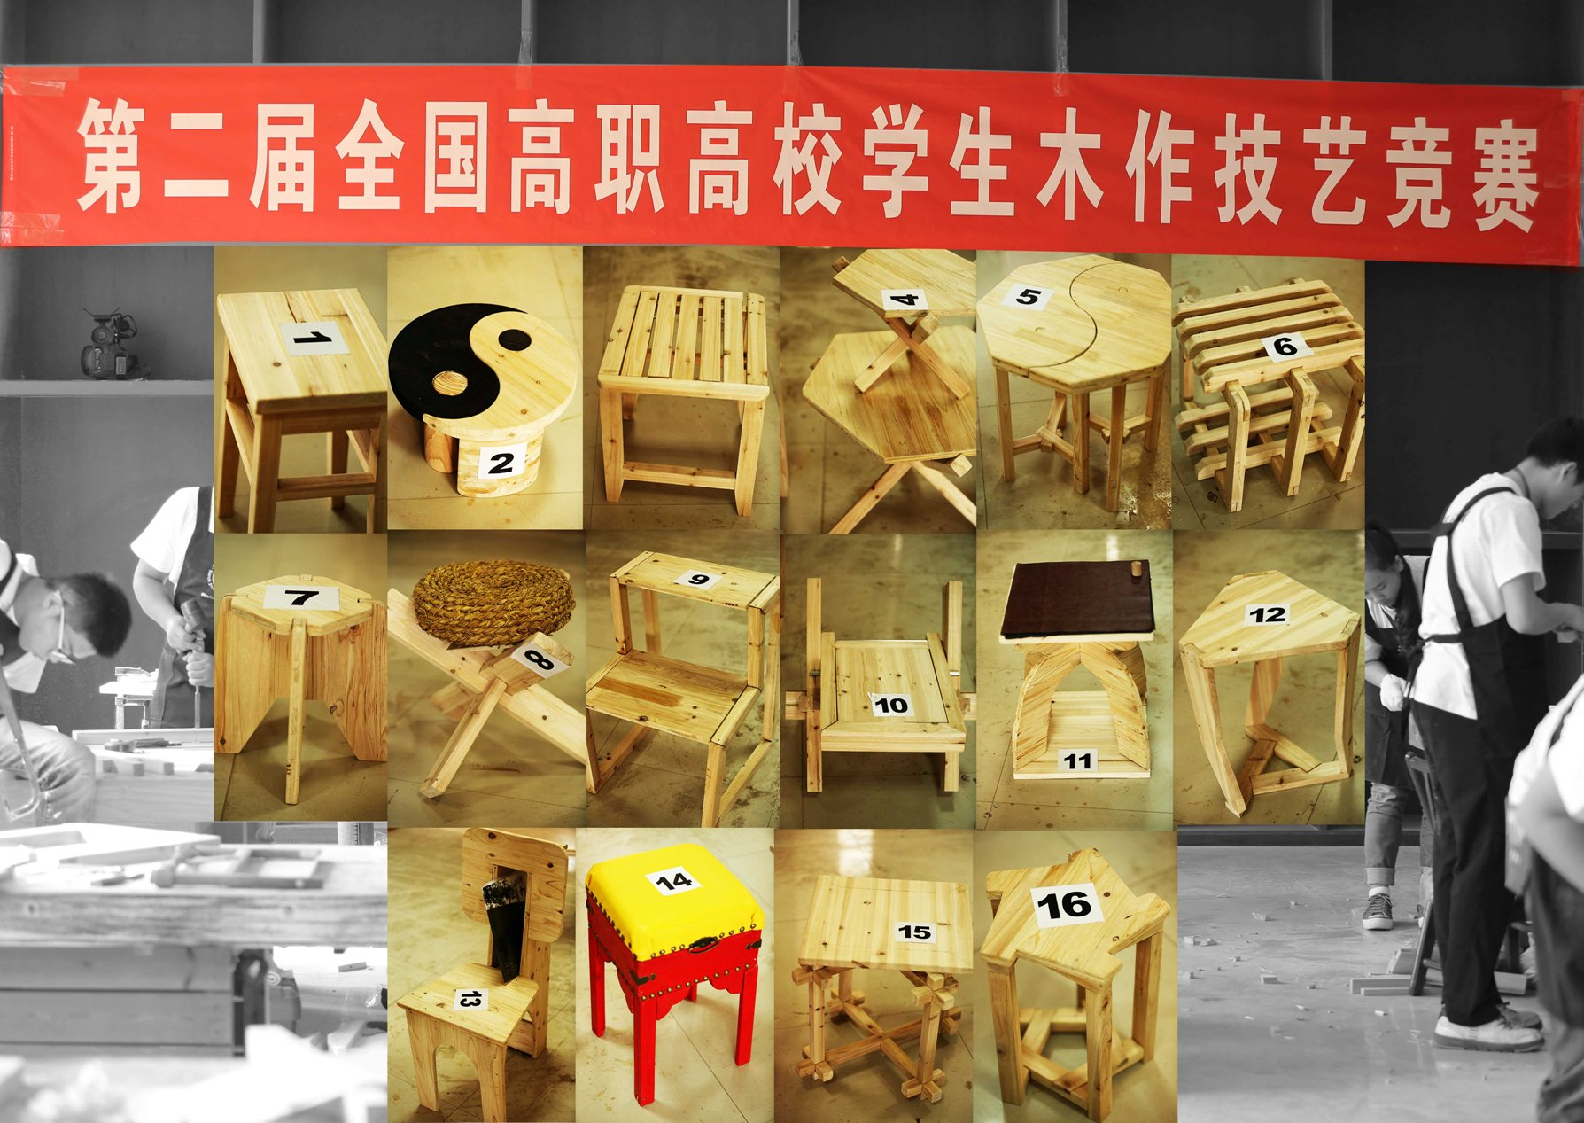
The 2013 International Wood Culture Symposium on Taxodiaceae was held in Changsha, China with over 100 attendees. For the first time, multidisciplinary discussions on Taxodiaceae raised issues about the current taxonomic system, historical usage, indigenous beliefs, natural forests and tree plantations, biodiversity conservation, markets and industrial development, and the future sustainability of the species in this family. A student youth woodworking competition was also held. Students had 4 hours to complete a stool from Chinese Fir. The entries are shown in the picture. Prior to the meeting was a pre-conference tour to Yueyang City, which included the Yueyang Tower with a wooden roof in the shape of a general's helmet. Four huge nanmu pillars support the entire building and the tower is constructed of wood with interlocking brackets that require no nails.

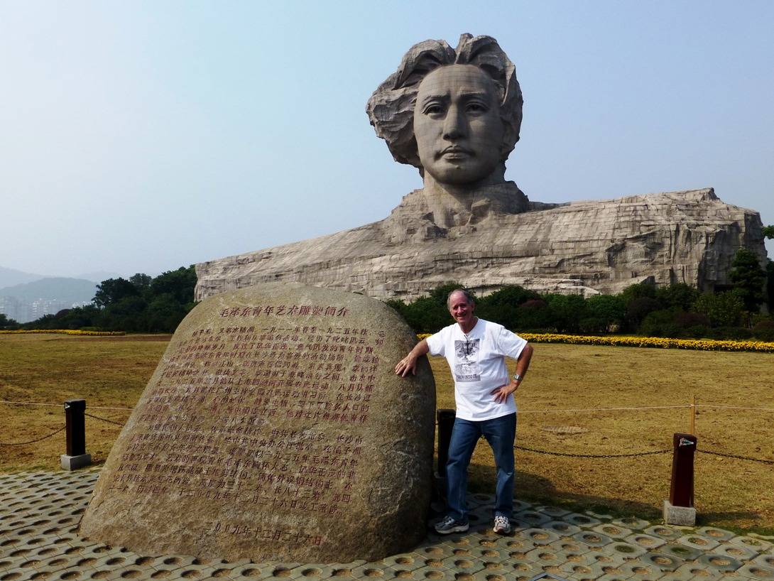
The tour also included the famous Yuelu Academy established in 976 A.D. and now called Hunan University, the Jiandu (bamboo slips) Museum dating back thousands of years to the Han Dynasty, and Orange Island in the middle of the Xiang River that splits Changsha. Mao Zedong began his political career in Changsha and a statue on the Island commemorates him. The IUFRO Wood Culture Working Party 5.10.01 was a Supporter of this meeting. More information can be found on the website: http://www.wood.info/customPage/100002/activity/30/index.html.

Howard Rosen
IWCS – Vice President
IUFRO 5.10.01 Wood Culture Working Party Chair

- First picture – Yueyang Tower
- Second picture – Howard Rosen, Wood Culture Working Party Chair in front of Mao Zedong statue on Orange Island
- Third picture

