World Wood Day 2016 Celebration in Kathmandu, Nepal
Howard Rosen
Chair, IUFRO unit 5.10.01 (Wood Culture) and World Wood Day Foundation

Andrew H.H. Wong
Deputy Coordinator, IUFRO D5 (Forest Products)

Nature and Culture was the theme of the 2016 World Wood Day (WWD) held March 21, 2016 in Katmandu, Nepal, organized by both the Ministry of Forests and Soil Conservation of Nepal and The International Wood Culture Society (IWCS), with the sponsorship of the World Wood Day Foundation. That theme increased awareness of wood as an eco-friendly renewable biomaterial and demonstrated the key role of wood in a sustainable future. The theme explored the interrelationship between nature and culture that influences the way we use wood in our daily lives. IUFRO proudly supported the WWD program which is meaningful to the strategy of its Forest Products Division. Although WWD is celebrated on March 21st each year, three pre-events projects began as early as February 27th and other events continued until March 26th. About 500 people representing 100 countries and regions attended this event and over 40,000 local people participated. Andrew Wong (for IUFRO, right) and Howard Rosen (for World Wood Day Foundation, left) both spoke in the opening ceremony on both ends with the President of Nepal, Bidhya Devi Bhandari, in the center and Nepal Minister of Forests and Soil Conservation Agni Sapkota (2nd left, Pic 1).
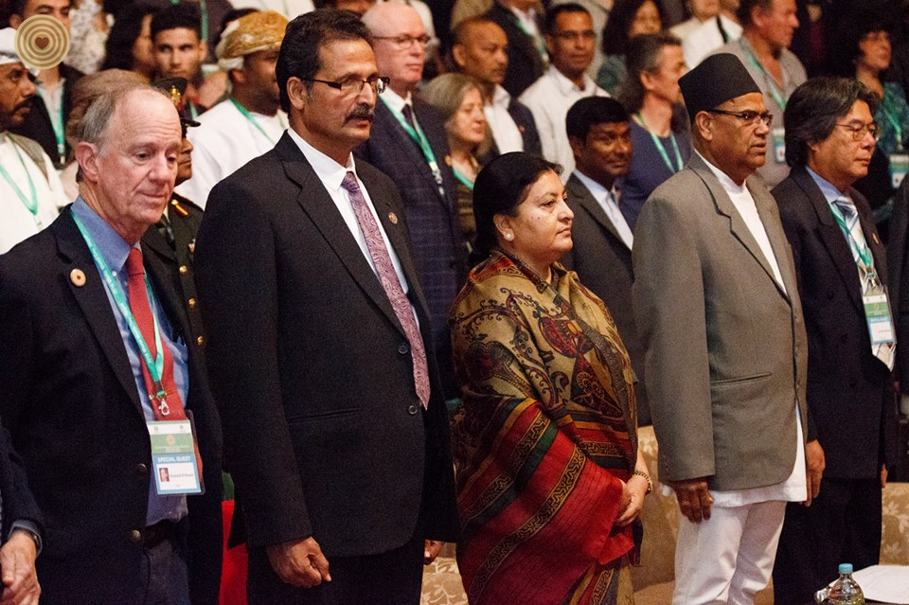
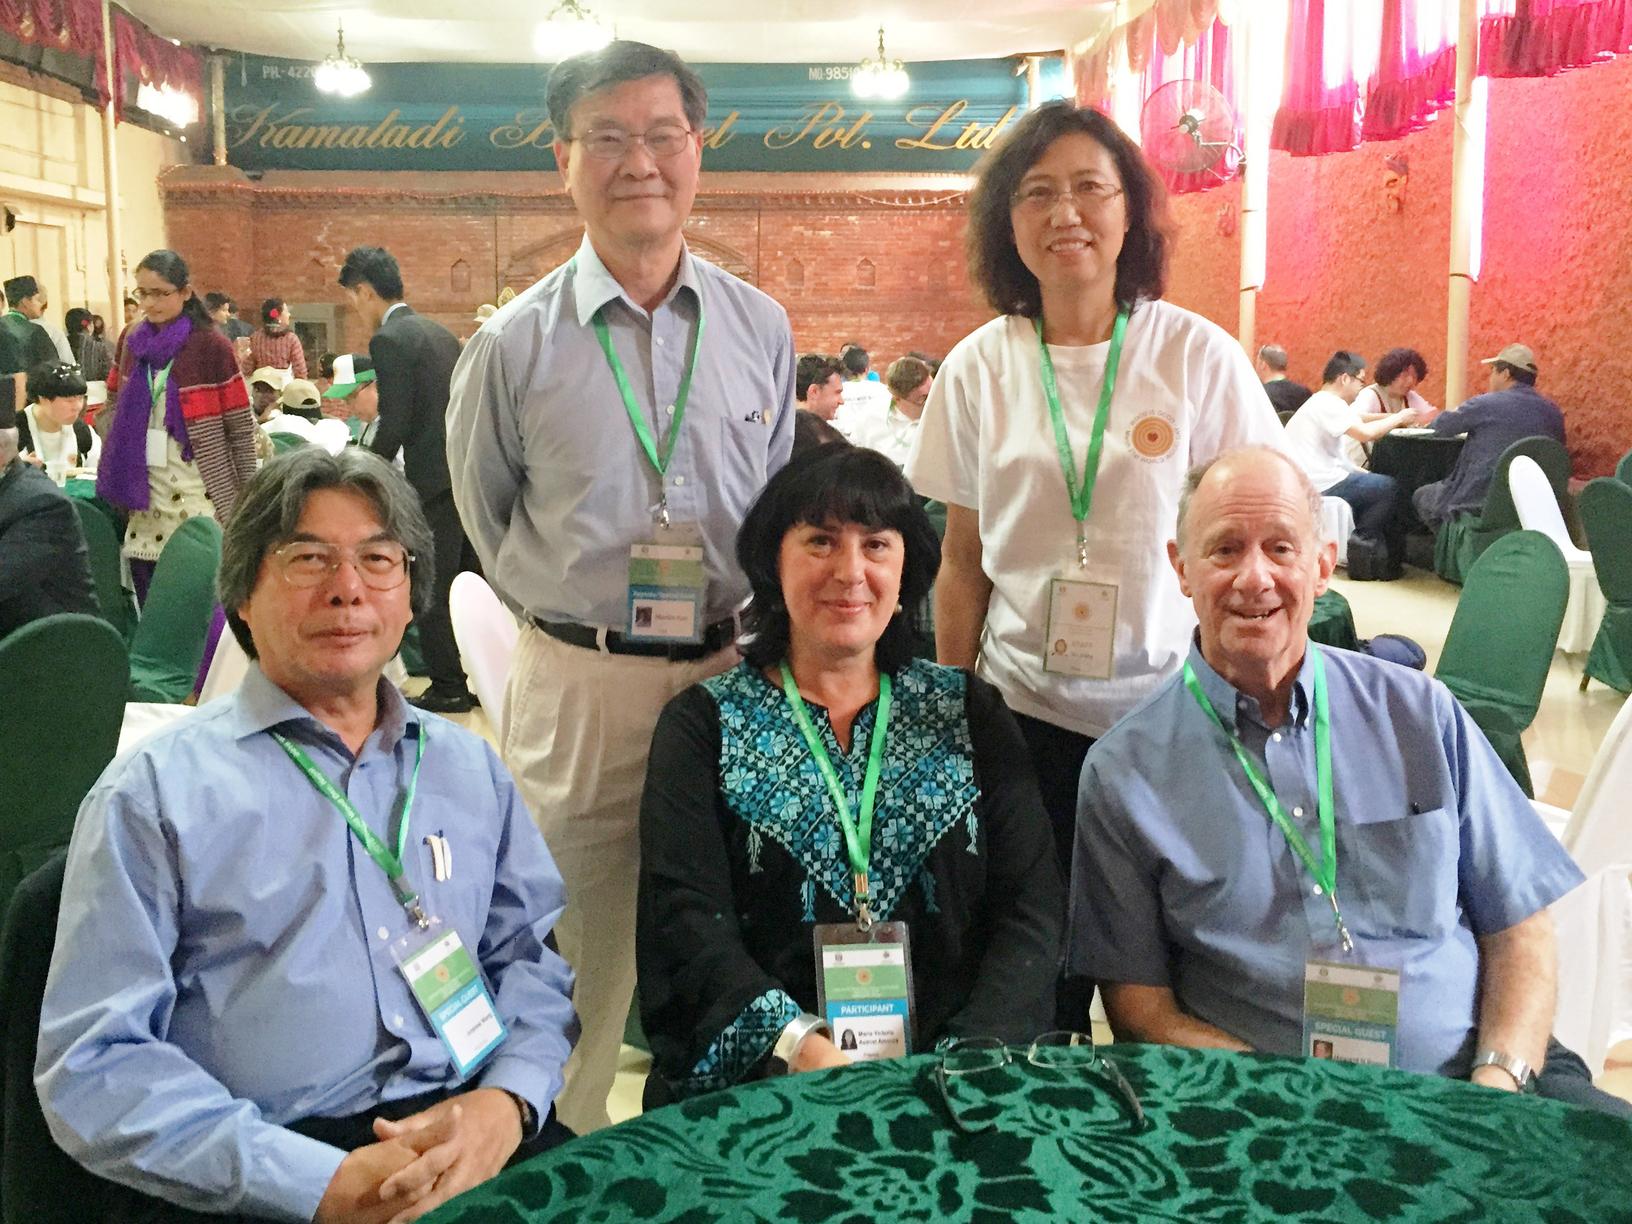

Pic 1: Opening ceremony speakers Pic 2: IUFRO attendees: back -Mon Lin Kuo. Jinling Su. Front-Andrew Wong, Maria Victoria Asensi Amoros, Howard Rosen

The WWD event also received the cooperation of an exhaustive list of key organizations aming which are: Department of Forests Nepal, the International Union for conservation of Nature (IUCN) Nepal, World Wide Fund for Nature (WWF Nepal), Safe the Planet Nepal, International Center for Integrated Mountain Development (ICIMOD), Tribhuvan University, Katmandu University, Global Alliance of Community Forestry (GACF), Federation of Forest Based Industry and Trade Nepal, Federation of Nepalese Chamber of Commerce & Industry, Nepal Foresters’ Association (NFA), Nepal Furniture & Furnishing Association (NFFA), Nepal Plywood Manufacturers Association, American Association of Woodturners (AAW), Japan Wood Research Society (JWRS) and the International Association of Wood Anatomists (IAWA). The main event was held at the Nepal Academy in the center of Kathmandu, that consisted of the Hall which enclosed displays, concerts, symposium presentations, exhibitions, and ceremonies; and the large Outdoor Squares where wood carving, wood turning, furniture making, folk art, a children’s wood education event, special wood architecture projects, and individual musical performances were held. A 3-day technical symposium under the theme of Nature and Culture: Interdisciplinary Approaches to Peaceful Coexistence and Sustainable Development featured 24 international and 19 Nepali experts who spoke on wood technology, innovations in wood and fibre materials, choice of timber species for various wooden structures and wooden artefacts, historical and cultural significance of forest environments and wood products/materials, Nepali forest management strategies and forest landscape restoration for a greener future, designing with wood as an art-form, architecture of traditional wooden tall buildings in Asia, climate change effects on Himalayan forest vegetation and biodiversity, the damaging consequences of fire, earthquake and drought on forests and wood products, ancient civilization and present traditional woodcrafts, and much more. The topics focused on raising awareness of current issues and enhancing multidisciplinary discussions for the crucial role of wood in human civilization and the environment. The WWD program culminated with an entertaining evening concert at the Nepal Academy, of mainly cultural wooden musical performances from nearly all corners of the globe to delight delegates and the public. The day after the WWD program, a Tree Planting Ceremony, officiated by the Minister of Forests and Soil Conservation, saw many of the attendees and representatives of organizations in the WWD program, at the National Botanical Garden in Godawari, Lalitpur, planting saplings of various indigenous species to emphasize the need for a sustainable source of trees to continue making wood products. A Rhododendron arboretum (National flower of Nepal) sapling planted by Andrew Wong perpetually displays a visible IUFRO tag in the Garden. Attendees were then treated to a tour exploring particularly the historic Katmandu city square area of Patan that held some of the finest wood carvings and historic wooden buildings and temples of Nepal.

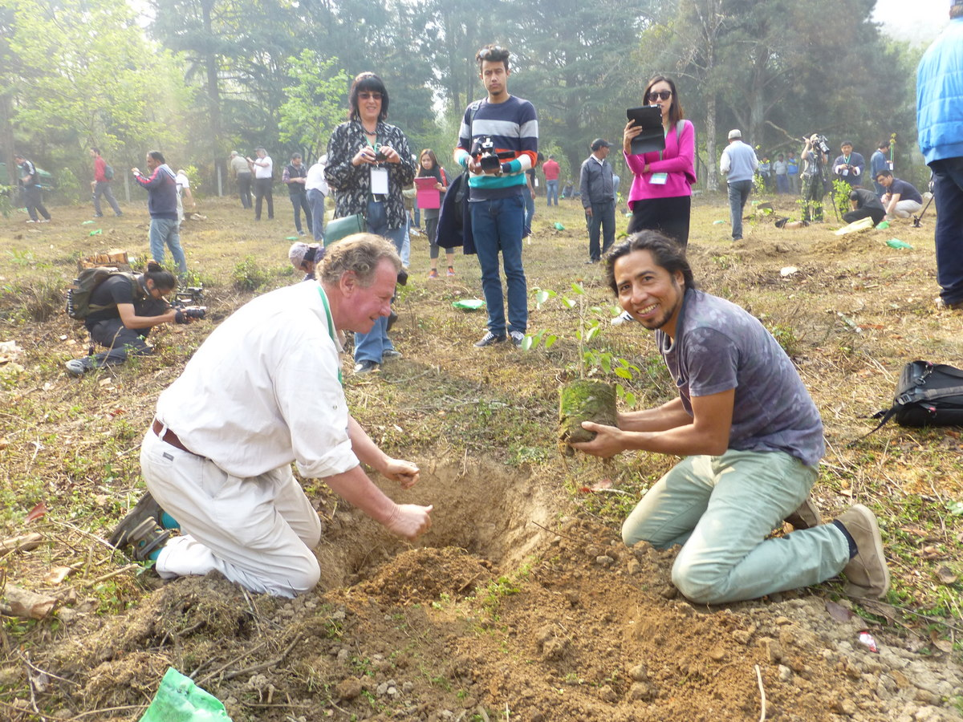

Pic 3: Allan Schwarz, Mozambique and Luis Antonio de Leon, Guatemala plant a sapling as part of the tree planting program in Godawari

Nepal had a major earthquake on April 25, 2015 and is still recovering from its aftermath. The city of Kathmandu is named after the Kasthamandap Temple that means “wood covered shelter” in Sanskrit. The temple was built entirely of wood with no iron nails or metal supports in the 16th century. According to legend, all the timber used to build the pagoda was obtained from a single tree. This temple collapsed during the devastating earthquake on April 25, 2015. Several unique projects of the 2016 WWD celebration from recycled Nepalese wood refuse reflected on this tragedy and hope for the future: an international, collaborative project with 19 artisans from 14 countries that designed and constructed a “Brick by Brick” wooden statue, two architectural projects; the Two-Tiered Temple (Nepal) and the Memorial Temple (US), and the “Elephant in the Room,” a US wood design project, which was made from recycled Nepalese refuse. From tours to central Katmandu and its environs, it was obvious that Nepal has suffered considerable damage from the 2015 earthquake and has a long recovery and restoration period ahead.

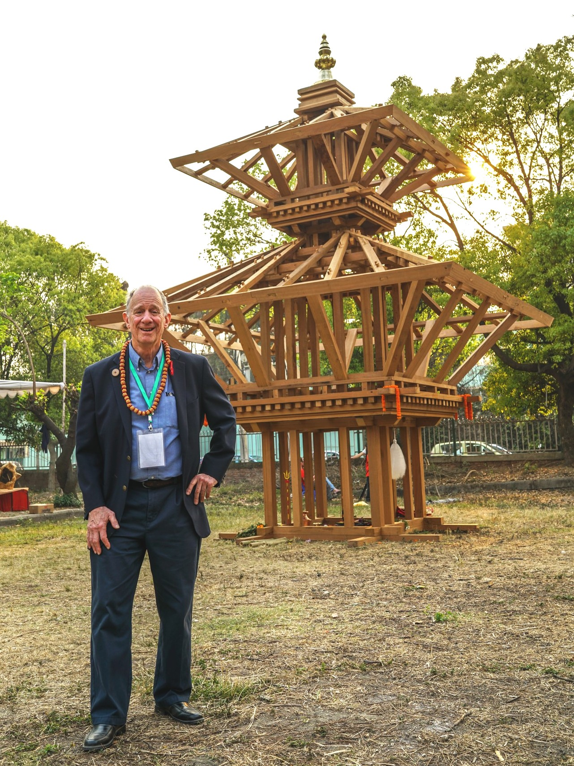

Pic 4: Howard Rosen in front of a smaller-scaled Two-Tiered Hindu Temple project designed and built by a Nepalese carpentry team

More details and pictures from these meetings and tours can be found at the World Wood Day 2016 websites http://www.worldwoodday.org/2016/ and https://www.facebook.com/worldwoodday.

