IUFRO Meeting Report Form

Organizers of IUFRO meetings and IUFRO focal persons at IUFRO co-sponsored meetings, respectively, are kindly requested to fill in and return this form within two weeks after the meeting by email (wolfrum@iufro.org), fax (+43-1-877 01 51-50) or mail (IUFRO Headquarters, c/o BFW, Hauptstrasse 7, 1140 Vienna, Austria). This information will be posted at the relevant IUFRO web pages and may be used for IUFRO News and the IUFRO Annual Report.

(Note: Save this file under a new name and write directly into the form.)

1) IUFRO focal person/meeting organizer:

Name: Howard N Rosen

Function in IUFRO: 5.15.00 Research Group Leader

Email: hrosen@fs.fed.us or howard.rosen@verizon.net

2) Meeting report (max. 100 words per paragraph)

Key issues discussed/latest findings in the field:

a) Research grant proposals
b) Wood culture symposium of 2 ½ days
c) International wood carving show with 80 carvers
d) International young adult furniture making invitational
e) Wood turning demonstrations
f) Wood design project
g) Folk art projects
h) International music festival
g) Children’s events
h) Tree planting
i) Photo contest

Conclusions (if possible, summarize key conclusions across presentations):
- Wood culture has been part of mankind since early civilization
- Wood culture encompasses all parts of human life
- Artistic wood crafts are part of most world cultures
- The importance of learning about wood at a young age is very important
- Our wood sources must be replenished by planting of new trees

Outlook to future activities (proceedings, future meetings, other):

Will have at least one meeting around March 21st to celebrate World Wood Day. Will participate in Division 5 meetings and World Congresses

Background information (meeting context):

World Wood Day is a cultural event celebrated annually on March 21st, the same day as the International Day of Forests, to highlight wood as an eco-friendly and renewable biomaterial and to raise awareness on the key role wood plays in a sustainable world through biodiversity and forest conservation. This unique celebration reminds us all the importance and true value of wood and its responsible uses. The previous five celebrations were held in Tanzania, China, Turkey, Nepal and the United States. The overall theme of WWD 2018 was “Life” to represent the use of wood in all aspects of people’s lives. The Mekong River Delta was chosen as the area of the world to emphasize and Siem Reap, the ancient capital city of the Khmer civilization from the 9th to the 15th century was the main city for the 2018 celebration. The sites in Angkor are marvels to behold in today’s world including Angkor Wat, Angkor, and Ta Prohm, where the roots of the spung tree grows through and around the ancient structures. The temples of Angkor made a spectacular setting for the events of WWD 2018. Highlights included about 90 wood carvers and wood turners and the collaborative project involving 14 people from 10 countries to make a unique wooden structure. Wood carvers worked in groups of three to make intricate carvings from large slabs of wood. The WWD celebration were extended to programs in Vientiane, Laos, March 29-April 1 and Mandalay, Myanmar April 6-8.

3) Other information:

Meeting data:

Full title of the meeting: 2018 World Wood Day

Date and venue: March 20-26, 2018, Siem Reap, Cambodia

Meeting website: http://www.worldwoodday.org/2018/

Number of participants: About 550

Countries represented: about 100

Organization of the meeting:

All IUFRO Units involved: 5.15.00 Forest Products Culture

Host organization(s) and sponsor(s): World Wood Day Foundation (host), sponsors: IUFRO, IAWA, Institute of Wood Science and Technology, Japanese Wood Research Society, American Association of Woodturners

Study tour(s) to: Angkor Wat, Angkor Thom, and Ta Prohm Temples

Communication activities (dissemination of information about the meeting; promotion of IUFRO):

IUFRO had one session during the Symposium titled: IUFRO Forest Products Research Group Colloquium

Related publications /websites: https://www.facebook.com/worldwoodday.

4) Photos

- Legend: Spung tree roots (Tetrameles nudiflora) growing on a temple wall in Angkor, Ta Prohm
- IUFRO 5.15.00 Forest Products Culture officers at the Angkor Century Resort and Spa. l. to r, Chai Hua Lee, Howard Rosen, Andrew Wong, Michael Grabner, Su Jinling, Ping Yang

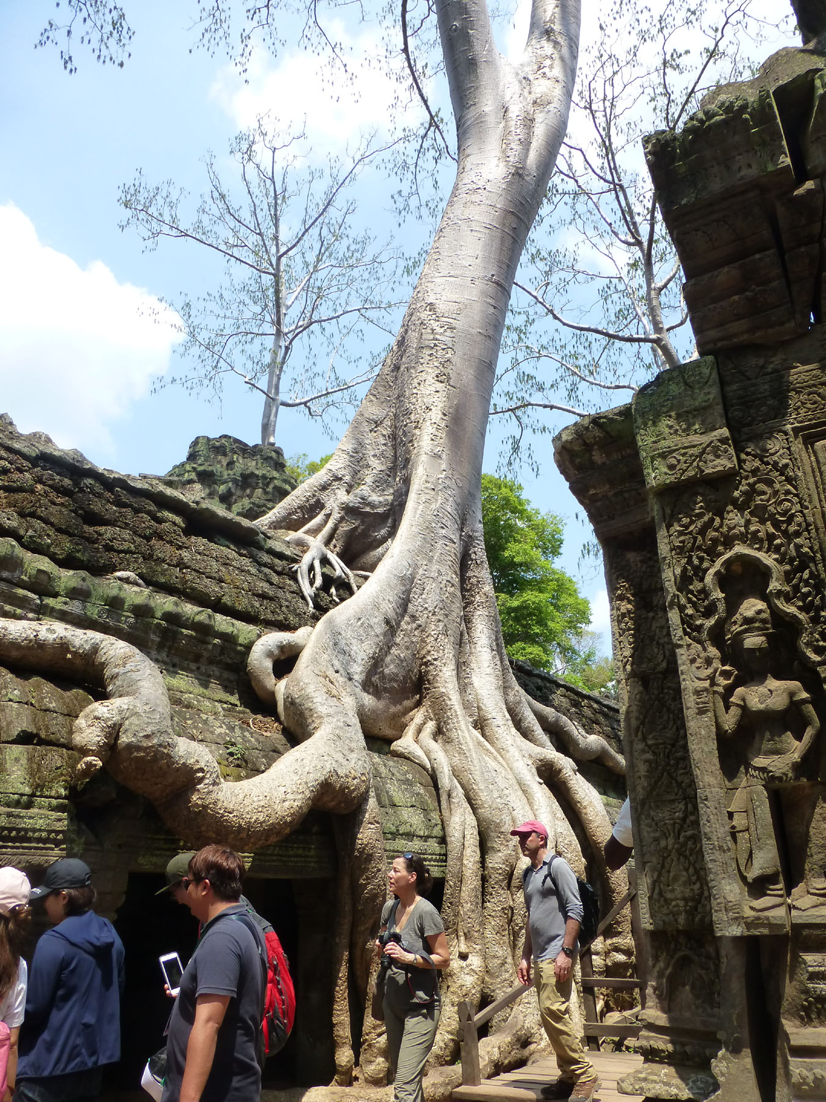

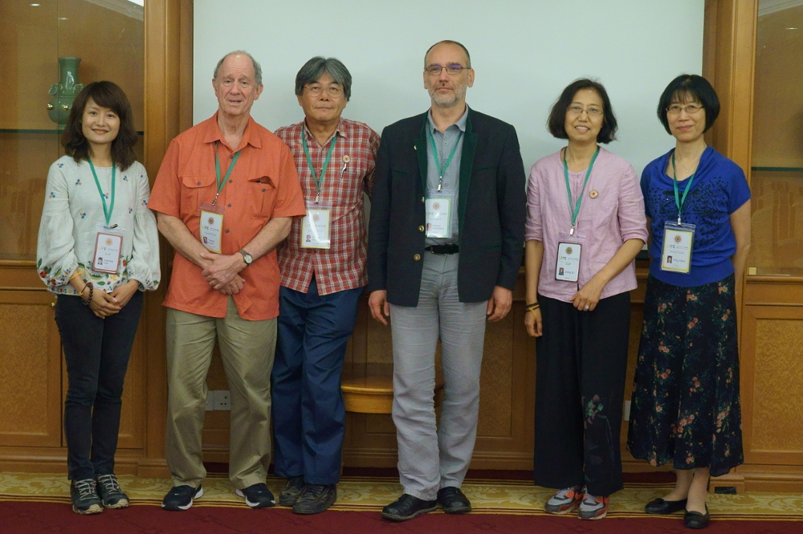
Copyright: World Wood Day Foundation

