IUFRO Symposium on Forest Education – Merging theory and practice with help of digital tools

**Time**: October Mo 2 – Wed 4, 2023

**Place**: University of Helsinki (Helsinki in Viikki campus and field station Hyytiälä), Lohja, Nemus Futurum visit by Metsä Group, Finland

**Organisers:**

IUFRO RG6.09 Forest education, Mika Rekola (chair) University of Helsinki (UH)

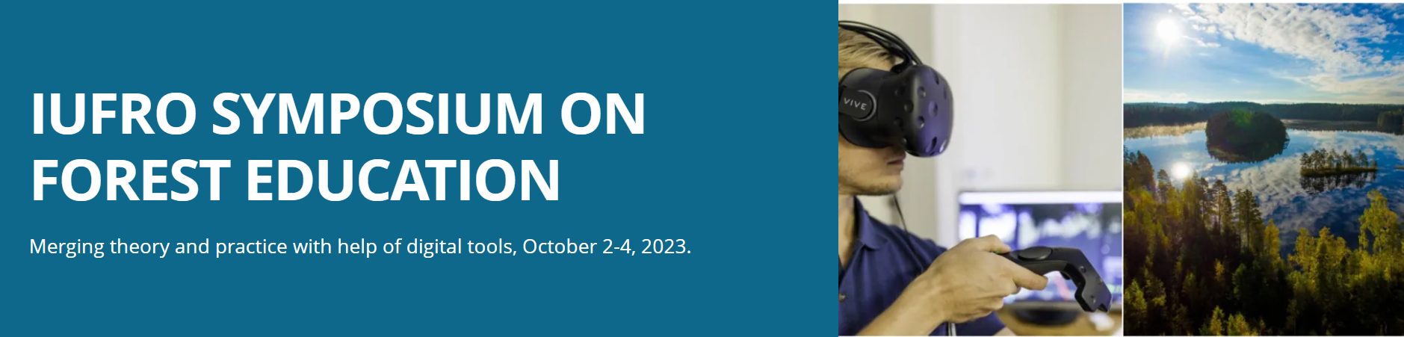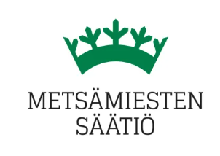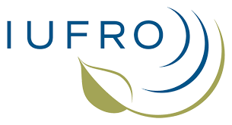

**

***REPORT*** *December 11, 2023*

The IUFRO Symposium on Forest Education consisted of invited keynotes and seminars, voluntary papers and round table discussions, short communications, field visits and teaching observations. These activities took place in Helsinki and other places in Southern Finland. Most activities were also communicated in hybrid mode.

Symposium participants discussed gaps in forest education at university and college level including further education, curriculum of forest education such as Forest Education Global Core Curriculum (FEGCO), and digital tools and platforms. The aim of the symposium was especially to discuss about

• how education could find best ways to combine theory and practice

• how digital tools could be used to enhance forest education.

Online degrees and micro-certificates offer an efficient approach to delivering forest education, particularly to professionals in the field. For instance, Oregon State University, a leader in this space, currently provides over a hundred online degree programs. However, integrating theory with practical experience necessitates the involvement of a wide array of stakeholders, additional instructional design resources, and the engagement of faculty members. Leveraging modern digital and mobile technologies has demonstrated the feasibility of online forest education, as showcased during the IUFRO 2023 Symposium on Forest Education in Finland.

The IUFRO Symposium on Forest Education was a multifaceted event, encompassing invited keynotes, seminars, voluntary paper presentations, roundtable discussions, short communications, field visits, and teaching observations. These activities took place in Helsinki and other locations in Southern Finland from October 2 to 4, and most were conducted in a hybrid format.

*Dianna Fisher*, representing Oregon State University (OSU) in the USA, delivered an informative overview of OSU's extensive experience in distance education and shared insights on how to develop a successful online program. OSU boasts a 25-year history of providing complete university degrees online, now offering over 100 programs, including several in the field of forestry. Dianna underscored the critical role of instructional design in amalgamating the best learning theories, design methodologies, and digital tools.

Rob Kozak delivering concluding remarks. Photo: Mika Rekola

*Pipiet Larasatie* from the University of Arkansas, USA, discussed the planning process for a new, highly flexible adult continuing education business model—the HyFlex graduate program in Forest Business. This program will allow students to study in person, participate in real-time online classes, and access recorded lectures.

*Jorma Neuvonen*, representing the University of British Columbia (UBC) in Canada, presented the need for and plans related to micro-certificate programs for continuing education. In British Columbia, both professional requirements and personal reasons drive non-degree learning, making it mandatory for registered professional foresters to engage in and report continuing professional development annually.

*Sandra Sharry* from Universidad Nacional de la Plata explained forest education policies in Argentina, addressing challenges related to new quality standards and the incorporation of ICTs. These policies include accreditation standards for degrees, with challenges such as a low number of graduates and extended graduation timelines.

In addition to the aforementioned keynote addresses 10 voluntary presentations were delivered. Topics included for instance wood science education (*Higashihara Takashi*) and forest sciences programmes’ curricula analysis (*Mariko Inoue*) in Japan. Joint master’s degree programmes in Asia Pacific (*Wang, Guangyu* and *Zeng, Suzy)* and in Europe (*Marjoriitta Möttönen and Isabel Muñoz Hidalgo*) were touched upon to show the power of educational networks. *Ari Talkkari* and *Ilkka Korpela* delivered presentations about forest management teaching in Finland.

Presentations from Latin America covered experiences and reflections from teaching forest economics in Costa Rica (*Sergio Molina-Murillo*), gender issues in forestry education in Brazil (*Claudia Moster*), and forestry education in Mexico (*Lujan Alvarez*).

A presentation from Poland by *Laroslaw Bator* focused on the tools provided by the State Forest Service for forest and park visitors, highlighting the immersive potential of virtual reality (VR) in conveying information and emotions compared to traditional media.

*Rob Kozak*, the Dean of UBC College of Forestry, delivered the closing remarks, emphasizing the role of AI in formulating teaching strategies and the importance of education as a means to transfer scientific knowledge from theory to practice.

The Symposium also featured short presentations from forest educational organizations in Finland, including TAPIO (*Reetta Pihljerta*), Metsäkoulutus ry (*Mika Rekola*), Metsäkeskus (*Tuula Jusko*), and the Department of Education at the University of Helsinki (*Anne Nevgi*).

Nemus Futum visit. Photo: Mika Rekola

Furthermore, the working agenda of the IUFRO research group "Forest Education" RG6.09 was presented by RG coordinator *Mika Rekola* from the University of Helsinki. The key topics in the agenda revolved around international peer-review systems for university teachers, global core curricula, and the development of a forest science undergraduate-level textbook based on these discussions.

Field teaching observation in Hyytiälä. Photo: Mika Rekola

The event included visits to digital education (augmented reality) at Metsä Group in Lohja's Kirkniemi and a unique forest education observation experience. In the University of Helsinki field station Hyytiälä teachers *Ilkka Korpela* and *Mika Rekola* imparted knowledge on ecosystem services and forest measurements to the first-year forest sciences' BSc students, offering a practical culmination to the symposium.

Symposium was sponsored by Metsämiesten Säätiö Foundation.

Further information: <https://www.helsinki.fi/en/conferences/iufro-symposium-forest-education>