Re: SPOTLIGHT “Supersites for Superior Forest Science”

Authors: R. Matyssek¹*, E. Paoletti²*, A. Bytnerowicz², A.R. Kozovits¹, G. Wieser¹, Z. Feng¹

¹ IUFRO WP 7.01.02
² IUFRO RG 7.01.00
* coordinators: matyssek@wzw.tum.de; paoletti.cnr@gmail.com

Anthropogenic pressure on forest ecosystems continues to increase worldwide through effects of climate changes. IUFRO Research Group 7.01. and the EU-funded COST Action FP0903 “MAFor” warn in a recent book release (Matyssek et al. 2013, see below) that air pollution has largely been neglected as an intrinsic component of climate change. This omission represents one major impediment towards a comprehensive process-based understanding of forest ecosystem adaptation capacities to anthropogenic changes and for effect mitigation. Ultimately, such understanding is a pre-requisite for reliable risk assessment and development of science-based management strategies.

Need of action was identified for
- unifying the largely unrelated research on climate/global change and air pollution effects on forest ecosystems, based on analytical state-of-the-art field instrumentation;
- integrating experimental, monitoring and modelling assessments at key forest sites under large-scale and long-term perspectives;
- establishing mechanistic understanding of inter-related feedbacks between climate change, air pollution and forest ecosystem response for science-based management practices and risk assessment;
- adjoining integrative research concepts that analyze ecologically and/or economically relevant types of forest ecosystems across continents and hemispheres under combined climate change, land use and air pollution scenarios;
- building global collaboration networks and coordination structures in defining and conducting research and harmonizing methodological infrastructures.

Supersites for Forest Science were postulated and proclaimed in the book release, integrating several publications on the subject by MAFor and IUFRO RG 7.01 members since 2011 (see below), for overcoming identified deficits and meeting the outlined need of action. Elaborated process-based evidence is to be transferred beyond research communities and adapted, in particular, to use in practice for stand management and risk assessment.

Adequacy of forest supersite science has been identified for five focal areas:
Focus I: Interactions and effects of trace gases and climate change
Focus II: Significance of biotic interactions in forest ecosystem response
Focus III: Tools for mechanistic and diagnostic understanding
Focus IV: Unifying modelling and empirical assessment through integrative concepts
Focus V: Global dimension of air pollution as part of climate change

The envisioned research may imply use of eddy flux, free-air gas exposure (e.g. CO₂/O₃) and/or rainfall exclusion technologies. Biotic interactions comprise competition with transitions to facilitation under stress, mycorrhization, microbial including pathogenic interactions and impacts of insects. Hence, close cooperation with IUFRO RG 7.02 (pathology) and RG 7.03 (entomology) is under preparation.

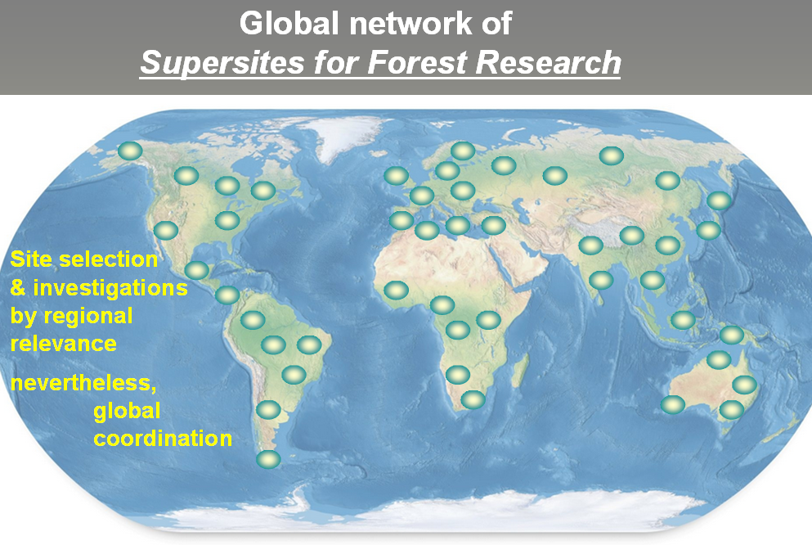
Particular attention is directed to arising new “hot spots” of interactive climate/global change and air pollution impacts in Eastern Asia and across the southern hemisphere (Focus V). Crucial questions pivot on (i) potential consistencies in forest ecosystem responsiveness across hemispheres, (ii) trans-hemispheric transferability of research needs and conclusions, and (iii) ecological significance of high species diversity as in the (sub-)tropical zonobiomes.

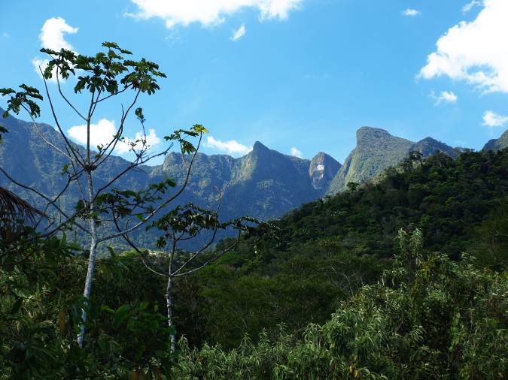
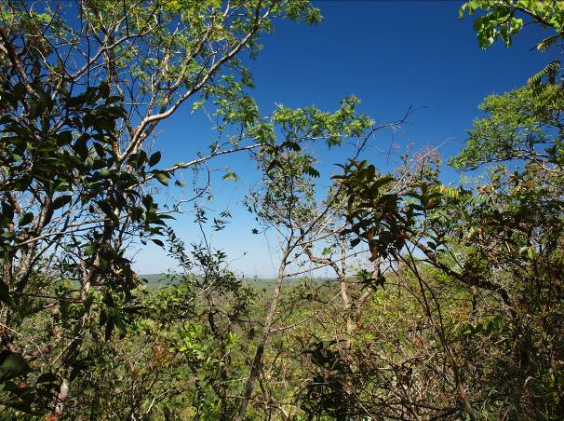
Particular need for “Supersites for Forest Science” in the sub-tropical zonobiome, exemplifying
Atlantic Forest (State of Rio de Janeiro/Brazil; left) and Cerradao (State of Sao Paulo/Brazil; right).
Photos: R. Matyssek

Analytical capacities of integrated experimental, exploratory and modelling approaches are to be used, including large-scale model validation by new experimental databases elaborated worldwide.

A 10-year horizon for initiating “Supersites for Forest Science” is conceived, conceptually and methodologically upgrading existing forest sites with long-established research history and linking them, at the global scale, with newly established ones - in particular across the (sub-)tropical zonobiome.

Highlighted book release:

Matyssek R, Clarke N, Cudlin P, Mikkelsen TN, Tuovinen J-P, Wieser G, Paoletti E, eds. (2013) Climate change, air pollution and global challenges: understanding and perspectives from forest research. Developments in Environmental Science 13, Elsevier, pp. 622 (in particular, chapters 22 & 23)

Preceding publications on the subject comprehended by the book:
Clarke N, Fischer R, de Vries W, Lundin L, Papale D, Vesala T, Merilä P, Matteucci G, Mirtl M, Simpson D, Paoletti E (2011) Availability, accessibility, quality and comparability of monitoring data for European forests for use in air pollution and climate change science. iForest – Biogeosciences and Forestry, 4: 162-166.
Danielewska, A., Clarke, A., Olejnik, J., Hansen, K., de Vries, W., Lundin, L., Tuovinen, J.-P., Urbaniak, M., Paoletti, E., 2013. A metadatabase comparison from various European Research Networks dedicated to forest sites. iForest - Biogeosciences and Forestry 6: 1-9

Fischer R, Aas W, De Vries W, Clarke N, Cudlin P, Leaver D, Lundin L, Matteucci G, Matyssek R, Mikkelsen TN, Mirtl M, Öztürk Y, Papale D, Potocic N, Simpson D, Tuovinen J-P, Vesala T, Wieser G, Paoletti E, (2011) Towards a transnational system of supersites for forest monitoring and research in Europe – an overview on present state and future recommendations. iForest iForest – Biogeosciences and Forestry, 4: 167-171

Matyssek R, Wieser G, Calfapietra C, de Vries W, Dizengremel P, Ernst D, Jolivet Y, Mikkelsen T.N, Mohren G.M.J, le Thiec D, Tuovinen J-P, Weatherall A, Paoletti E (2012) Forests under climate change and air pollution: Gaps in understanding and future directions for research. Environmental Pollution 160:57-65.

Matyssek R, Mohren G M J (2012) Special topic: integrating modelling and experimentation. Trees 26: 1679-1682.
Paoletti E, Tuovinen J-P (2011) COST Action FP0903:Research, monitoring and modelling in the study of climate change and air pollution impacts on forest ecosystems. iForest – Biogeosciences and Forestry, 4: 160-161.
Flanking publication:

Matyssek R, Kozovits AR, Schnitzler J, Pretzsch J, Dieler J, Wieser G (2014) Forest trees under air pollution as a factor of climate change. In: Tausz M, Grulke N. (Eds.) Trees in a Changing Environment: Ecophysiology, Adaptation and Future Survival, Springer, pp. 117-163

