
You are invited to a virtual HLPF Side Event
Forests and transformative pathways to sustainability
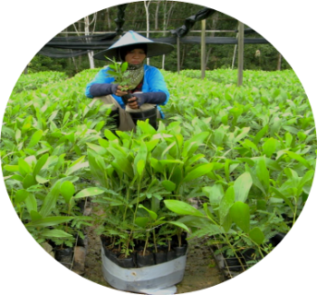
Thursday, 9 July 2020, 8:00-9:00 am EDT
(Eastern Daylight Time) / UTC/GMT -4 hours
Join us via this link:
https://events.icareus.com/fi/web/bright/player/event/custom?eventId=60146361
Forests can be directly or indirectly linked to almost all SDGs and are central for nature based-solutions and transformative pathways towards sustainability. Building on the work undertaken by the International Union of Forest Research Organizations (IUFRO) Special Project World Forests, Society and Environment (WFSE) and especially the recent publication Sustainable Development Goals: Their Impacts on Forests and People, this side event will discuss the role of forests and forestry in transformative change and ways to accelerate the progress towards sustainability. It will specifically discuss the role of forest in transformational change and the levers of change across complex systems and illustrate ways to accelerate transformative change for the forests-food-energy-climate nexus and their potential and limitations, with emphasis on equity, gender and governance. It will also illustrate the large potential for synergies among the SDG targets that focus on sustainable land and resource use and the importance of policy and regulatory environment and capacities that support and incentivize sustainable forest-related livelihoods and development.
Programme
- Opening of the event and welcome Dr. Glenn Galloway, University of Florida
- Opening remarks Jukka Salovaara, Ambassador, Permanent Representative, Permanent Mission of Finland to the United Nations

- Forests and forestry in transformational change Prof. Wil de Jong, Kyoto University
- From forest-specific sustainability to wider transformative change: Levers of change across complex systems Dr. Pablo Pacheco, World Wildlife Fund
- Advancing commitments to leave no one behind: Focus on equity, gender, governance Dr. Bimbika Sijabati Basnett, Center for International Forestry Research Associate
- Forests and SDGs: Building on synergies for transformative change Dr. Pia Katila, Natural Resources Institute Finland
- Discussion
The event is organized by IUFRO, WWF, Ministry for Foreign Affairs of Finland, Natural Resources Institute Finland.
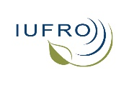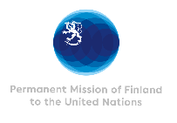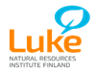

Link to the publication: Sustainable Development Goals: Their Impacts on Forests and People
and related policy brief
Contact: Dr. Pia Katila IUFRO-WFSE Coordinator, Natural Resources Institute Finland, pia.katila@luke.fi

