IUFRO Meeting Report Form

Organizers of IUFRO meetings and IUFRO focal persons at IUFRO co-sponsored meetings, respectively, are kindly requested to fill in and return this form within two weeks after the meeting or by a given deadline by email (wolfrum@iufro.org). This information will be posted at the relevant IUFRO web pages and may be used for IUFRO News and the IUFRO Annual Report.

(Note: Save this file under a new name and write directly into the form.)

1) IUFRO focal person/meeting organizer:

Name: IEFC
Function in IUFRO: Communication Manager
Email: communication(at)plantedforests.org

2) Meeting data:

Full title of the meeting: Webinar: Let’s Talk About Planted Forests: Forest Risk and Insurance
Date and venue: 19/01/2024
Meeting website: Videoconference
Number of participants: 67 participants
Countries represented: 35 countries represented
Webinar replay: https://www.plantedforests.org/webinars-replays/19-01-2024-lets-talk-about-planted-forests-forest-risk-and-insurance/ (access restricted to IEFC members)

3) Organization of the meeting:

All IUFRO Units involved: Resilient Planted Forests Serving Society & Bioeconomy
Host organization(s) and sponsor(s):
Study tour(s) to:

4) Meeting report (max. 100 words per paragraph)

- Background information (meeting context)

Global change is increasing and diversifying the risks that threaten European forests: drought, insects, fire, storms, hail, etc. In the case of planted forests, where an investor is betting on the future, the role of insurance in protecting against these risks is essential. However, we have observed that in some countries the level of risk is calling into question the principle of insuring forests, so it seemed appropriate to invite insurance experts to share their views on the future role of insurance in forests.

To discuss this subject, the IEFC invited 3 speakers:

- Guillaume Bouffard, MISSO GROUPAMA: “Recent bushfires in Australia and France : lessons learnt for an insurer specialising in Forest risks”
- Phil Cottle, ForestRe Ltd. Protecting your forestry investment – Overview of climate, loss profiles, extremes & risk management
- Peter Welten, Swiss Reinsurance Company Ltd. : “The current forestry insurance market from a Reinsurance perspective”

- Key issues discussed/latest findings in the field (bullet points or text)
This short event (1.5h) was an opportunity to invite 3 experts to share their views and and exchange with the participants. The consensus was that most of the market for forest insurance is associated to planted forest where investors are ready to protect their investment. These forests represent only 7% of the forest worldwide and are poorly insured considering that the penetration is only of 5/10%.

- Conclusions (if possible, summarize key conclusions across presentations):
Speakers concluded that in a context were risks are increasing insurance and reinsurance are playing a major role to protect forest and make sure that investors don’t go away from this market. But the estimate of real risk for professional is complex and is clearly lead by extreme events frequency even if the monitoring of small size events is also required to better understand the reality of damages in forests. Debate was about business model of insurance and how to diversify the portfolio in a world with multiple risks was raised.

- Outlook to future activities (proceedings, future meetings, other):
Next let’s talks about planted fores will be about automatization and robot in plantations.

4) Photos

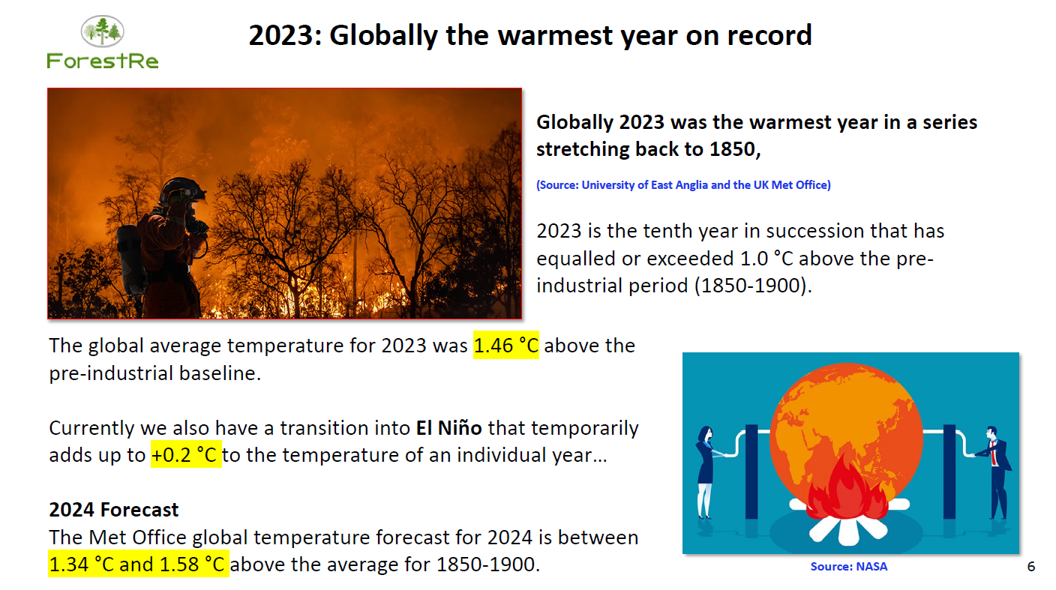

Caption: Presentation
Credit (protected by copyright): Phil Cottler, ForestRe

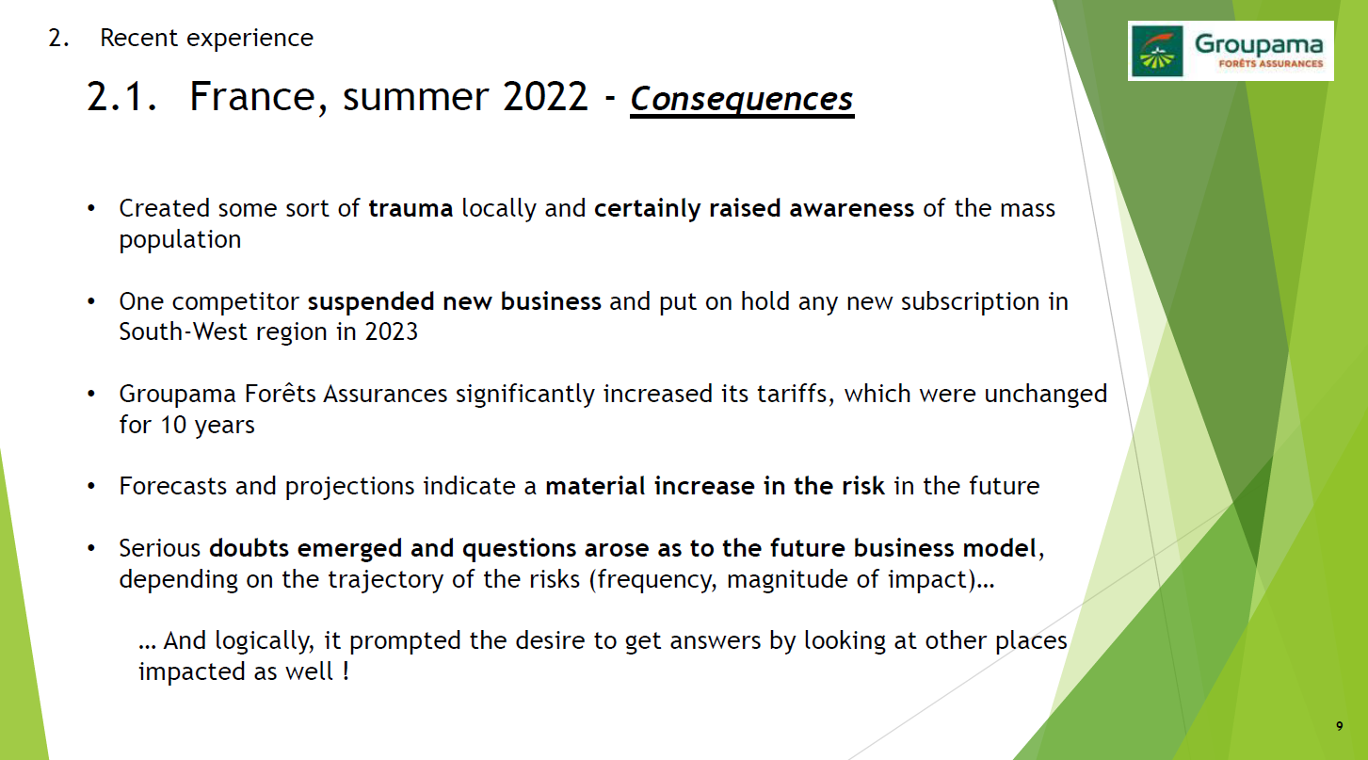
Caption: Presentation
Credit (protected by copyright): Guillaume Bouffard, MISSO GROUPAMA

5) Other information:

- Communication activities (dissemination of information about the meeting; promotion of IUFRO)

We promoted the webinar on social medias and on IEFC website. We also created an emailing campaign specific to this event with reminders. We informed IUFRO and EFI about this event, which was published on both websites.

- Related publications /websites
https://www.plantedforests.org/iefc-webinars-replays-lets-talk-about-planted-forests/

