IUFRO Meeting Report Form

Organizers of IUFRO meetings and IUFRO focal persons at IUFRO co-sponsored meetings, respectively, are kindly requested to fill in and return this form within two weeks after the meeting or by a given deadline by email (wolfrum@iufro.org). This information will be posted at the relevant IUFRO web pages and may be used for IUFRO News and the IUFRO Annual Report.

(Note: Save this file under a new name and write directly into the form.)

1) IUFRO focal person/meeting organizer:

Name: IEFC
Function in IUFRO: Communication Manager
Email: communication(at)plantedforests.org

2) Meeting data:

Full title of the meeting: Webinar: Let’s Talk About Planted Forests: Robot for Silviculture and Automatic Planting Machine
Date and venue: 29/03/2024
Meeting website: Videoconference
Number of participants: 17 (Unfortunately, a technical problem with the Zoom platform prevented many participants from joining the webinar. 130 participants had registered.)
Countries represented: 11
Webinar Replay IS OPEN ACCESS : https://www.plantedforests.org/webinars-replays/29-03-2024-robot-for-silviculture-and-automatic-planting-machine/
Webinar Replay views: 56

3) Organization of the meeting:

All IUFRO Units involved: Resilient Planted Forests Serving Society & Bioeconomy
Host organization(s) and sponsor(s): IUFRO & EFI (European Forest Institute)
Study tour(s) to:

4) Meeting report (max. 100 words per paragraph)

- Background information (meeting context)
Planted forests in most case are installed on bare soils, allowing a higher mechanization than naturally regenerated forests. In addition, as a result of plantation, forest pattern is more simple and regular than in other forests. Thus, planted forests are an interesting playground to test new robots, autonomous or not, to improve productivity at all stages of the forest management: plantation, weed control, thinning, harvesting. During this webinar, we do not pretend to give an exhaustive view but few examples of work in progress from different part of the world:

- Claire Stewart, Forest Growers Research, New Zealand: “An overview of the Precision Silviculture Programme from Forest Growers Research, New Zealand”
- Loïc Cotten, Alliance Forêts Bois, France: “Autonomous poplar planting machine developed by Alliance Forêts Bois”
- Harrie Lovenstein, Land Life, Netherlands: “Autonomous tree seeding: Aerial or Terrestrial?”

- Key issues discussed/latest findings in the field (bullet points or text)
This webinar was an unique opportunity do discover the ambitious R&D activities ongoing in New Zealand in relation to precision sylviculture covering autonomous stock monitoring, autonomous field robots, automatic seedling collection in nurseries, automatic spray, assisted thinning. LandLIfe company presented options explored to compensate manual labor lack for planting with an specific comparison between aerial versus terrestrial seeding. Allince-Forêt bois presented the planted machine designed for poplar regular plantations;

- Conclusions (if possible, summarize key conclusions across presentations):
Even if planted forest are a simple model, there is still lot of challenges to let machine evolves on their own to implement forest management activities. Yet development of new technologies allows a better monitoring with very accurate data collection to support decision making.

- Outlook to future activities (proceedings, future meetings, other):
We can assume that more and more project will appear in around the world, supporting precision silviculture and making forest workers life easier.

4) Photos

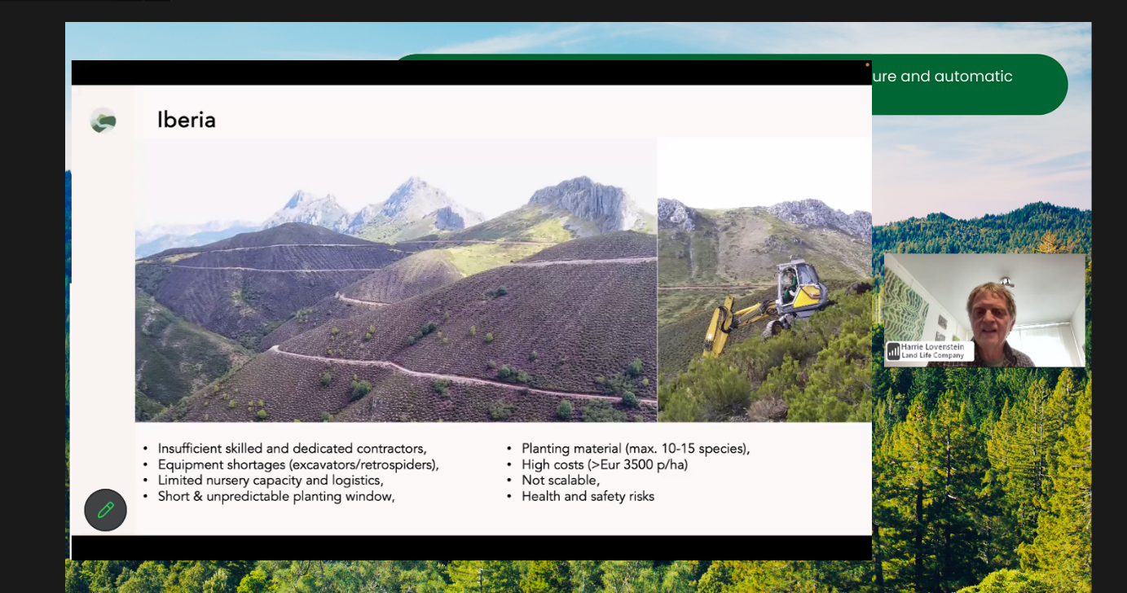
Caption: Presentation
Credit (not protected by copyright): Harrie Lovenstein

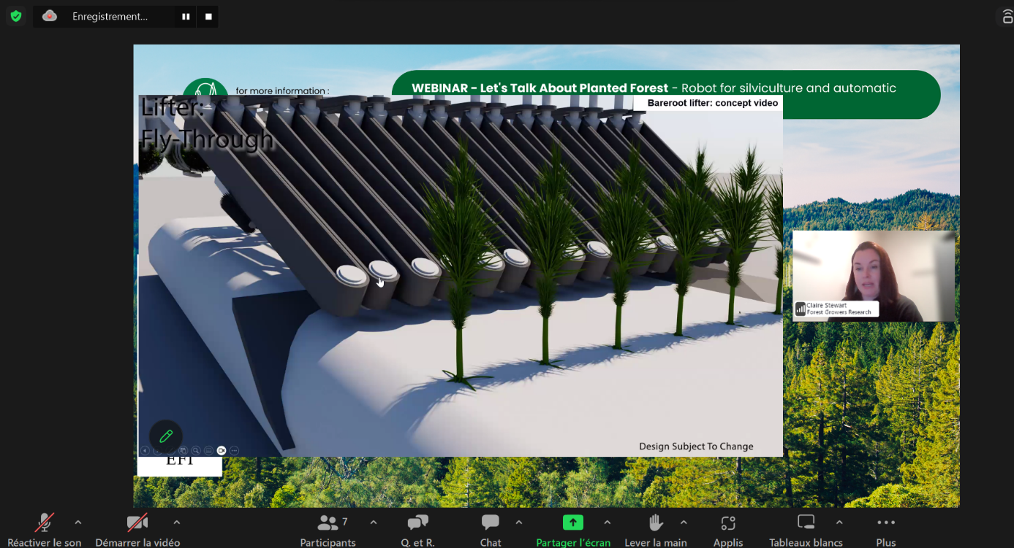
Caption: Presentation
Credit (not protected by copyright): Claire Stewart

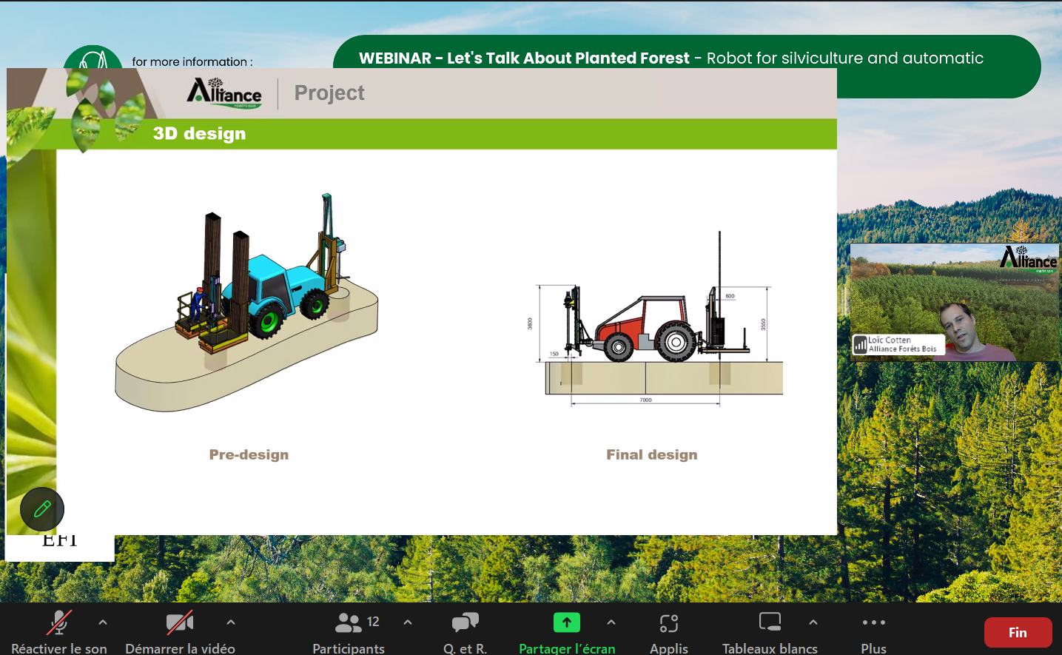

Caption: Presentation
Credit (not protected by copyright): Loïc Cotten

5) Other information:

- Communication activities (dissemination of information about the meeting; promotion of IUFRO)

We promoted the webinar on social medias and on IEFC website. We also created an emailing campaign specific to this event with reminders. We informed IUFRO and EFI about this event, which was published on both websites.

- Related publications /websites
https://www.plantedforests.org/iefc-webinars-replays-lets-talk-about-planted-forests/

